Guided Reading Map 2022-2023
Year Group | Autumn |  | Spring | Summer
EYFS  Year R | Children have carousel guided reading and phonics sessions. |  | Children have carousel guided reading and phonics sessions. | Children have carousel guided reading and phonics sessions.
Year 1 | Children have carousel guided reading and phonics sessions. |  | Children have carousel guided reading and phonics sessions. | Children have carousel guided reading and phonics sessions.
Year 2 | Voices in the Park – Anthony Browne  Ruby’s Worry – Tom Percival | The Barnabus Project – The Fan Brothers | Flat Stanley – Jeff Brown | Fantastic Mr Fox – Roald Dahl
Year 3 | Hodgeheg – Dick King Smith | The Iron Man – Ted Hughes | Firework Maker’s Daughter – Phillip Pullman | The Boy Who Grew Dragons – Andy Shepherd
Year 4 | Matilda – Roald Dahl |  | The Lion, the Witch and the Wardrobe – C.S. Lewis | Varjak Paw – S.F.Said
Year 5 | The Boy in the Tower – Polly Ho-Yen |  | Holes – Louis Sachar | War Horse – Michael Morpurgo
Year 6 | Skellig – David Almond | Floodland – Marcus Sedgewick | The Boy in the Striped Pyjamas – John Boyne | The Boy at the Back of the Class – Onjali Q Rauf
Why has this reading spine been chosen?
Reading is the cornerstone of our curriculum: we learn to read so that we can read to learn. Because of this, we place huge importance on our guided reading spine.
We have researched many different reading spine templates and models and have used the key principles from ‘Reading Reconsidered’ by Doug Lemov to develop our own reading spine based on the needs of our pupils. We want Firfield to be a place where children are read to, enjoy, discuss and work with high quality texts. To enable this, we have carefully selected our reading spine for guided reading to provide a progressive selection of books which can help to inform, support, enrich, inspire and act as a companion to the teaching of reading at Firfield Primary School. As the children progress through the reading spine, the books increase in complexity of language, structure and concepts. The intention is that is that by the time they reach Year 6 and beyond, they have developed a wide, rich vocabulary and broader knowledge of the world and, as a result, are able to access the more complex books expected of them in secondary schools.

In choosing the books, we focussed on our curriculum drivers which underpin the direction and development of all areas of school life:
- World Citizens
- Healthy Advocates
- Ambitious Thinkers
- Resilient Individuals
- Creative and curious minds

The deep exploration (book studies) of these core texts in guided reading acts to support the modelling of reading for pleasure and allows for shared experiences between learners of all abilities. It encourages children to expand their reading worlds, and for them to be introduced to authors whom they might not otherwise meet.
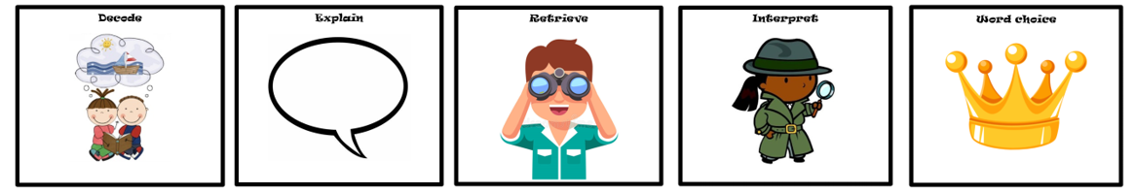
Across the school, we use the DERIC acronym to develop the reading skills required by the national curriculum and beyond.

These skills become more refined as the challenge of the texts and the themes they contain increases within and across year groups.
Our vision is for the list to evolve and grow year on year as it is influenced by the children’s appetite, staff recommendations and new publications.

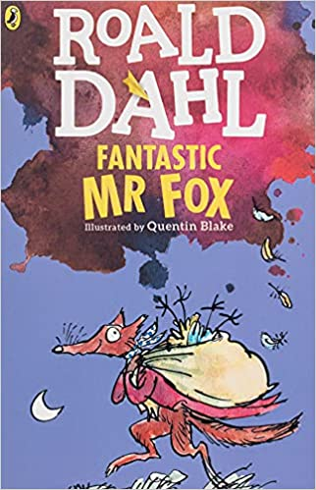
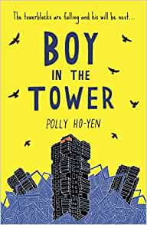
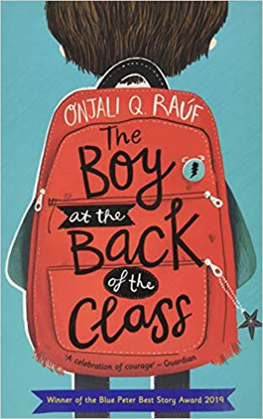
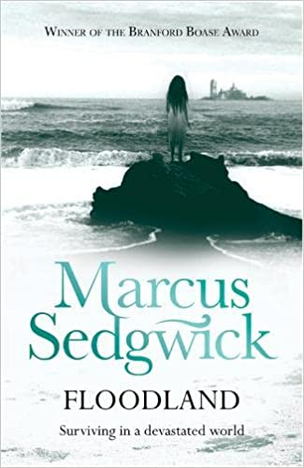
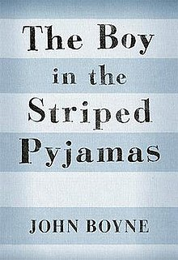
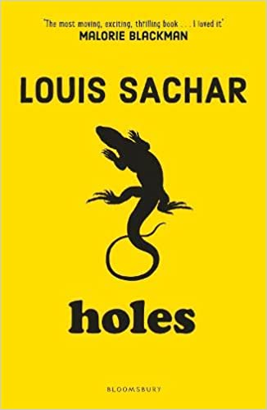
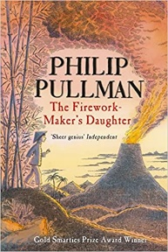
As an outward looking school, we know the importance of developing the children’s knowledge and understanding about where they live and the wider world. We have carefully chosen texts to develop the children’s understanding of their role in society and to develop respect towards the environment and diversity of different communities, religions and cultures.
We believe our pupils should be ambitious and embrace new challenges with drive and determination, so that they can confidently thrive and flourish. To help to develop the children’s resilience skills, we have carefully selected texts where characters face challenges and have to show perseverance and grow independence – life skills that we place great emphasis on at Firfield.

We believe that it is important to us that all members of our school community are healthy – physically and mentally. Throughout life, we face many different challenges and need to have mental and physical strength to be successful and happy. We have therefore carefully chosen texts which show the development of mental and physical strength in times of hardship, as well as texts with a theme of mental health.

Alongside developing the skill and knowledge, at Firfield we foster a love for learning through curiosity and have the freedom to share this creatively. We have carefully chosen texts which develop the children’s creative and curious minds.

We want our children at Firfield to have an understanding of the possibilities that are ahead. To learn about economic success, business enterprise and develop computer literacy to be able to adapt to the changing world to achieve our personal best. We have chosen texts which model ambitious thinking and thinkers to inspire our children’s minds to infinite possibilities.

