D  DERIC question stems and example questions: | 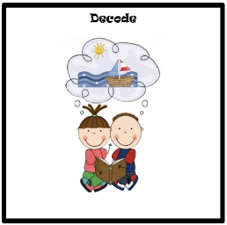  Apply your knowledge of letter-sound relationships, including knowledge of letter patterns, to correctly pronounce written words. | - How many sounds (phonemes) does this word have?  - How many letters does this word have?  - What could this word mean?
E | 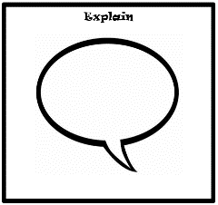  Explain how content is related and contributes to the meaning as a whole.  Explain how meaning is enhanced through choice of language.  Explain the themes and patterns that develop across the text.  Explain how information contributes to the overall experience. | - What does the word ______ mean?  - What other words could the author use instead of…?  - Can you summarise that paragraph/page in X words?  - What is the most important point in this paragraph?  - How is this similar/ different to another text you know?  - What happens first in the story? What happens next? Then? Etc…  - How does _____ feel at the start? Does _____ feel the same at the end?  - Why is the text arranged in this way?  - What structures has the author used?  - What is the purpose of this text feature?  - Is the use of ….. effective?  - The mood of the character changes throughout the text. Find and copy the phrases which show this.  - What is the author’s point of view?  - What affect does ….. have on the audience?  - How does the author engage the reader here?  - Which words and phrases did ….. effectively?  - Which section was the most interesting/exciting part?  - How are these sections linked?
R | Retrieve and record information and identify key details from fiction and non-fiction texts. | - How would you describe this story/text?  - What genre is it? How do you know?  - How did…?  - How often…?  - Who had…? Who is…? Who did….?  - What happened to…?  - What does…. do?  - How ….. is ……..?  - What can you learn from …… from this section?  - Give one example of……  - The story is told from whose perspective?
I | 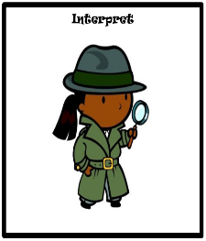  Make and justify inferences using evidence from the text. | - Find and copy a group of words which show that…  - How do these words make the reader feel?  - How does this paragraph suggest this?  - How do the descriptions of …… show that they are ……..  - How can you tell that……  - What impression of …… do you get from these paragraphs?  - What voice might these characters use?  - What was …. thinking when…..  - Who is telling the story?  - What do you think… means?  - Why do you think that?  - Could it be anything else?  - I think....; do you agree? Why/why not?  - Why do you think the author decided to...?  - Can you explain why...?  - What do these words mean and why do you think that the author chose them?  - How do other people’s descriptions of …show that…?  - Where else in the text can we find the answer to this question?
C | 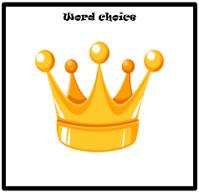  Unpick and justify the choices of the author, and their impact upon the reader. | - How does the writer describe…?  - What does the writer want us to think/feel?  - Why has the writer used that word/words?  - What are the writer’s views on…?  - Do you agree with the writer’s view?  - Why did the author choose that word?  - Why did the author choose to use… bullet points/subheadings etc?  - How has the author made you feel?

