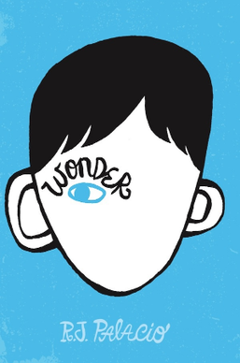
Vocabulary Check
Underline in:
Green - Words you know and understand.
Orange - Words you think you understand a little but need to know more.
Red - Words you don’t understand.

aversion Cleft Palate coincidence
extraordinary flabbergasted flounder hindsight
hysterical imitating meticulously
mutation obnoxious precept

