Key Vocabulary
aversion | A strong dislike or disinclination
Cleft Palate | A split or indentation on the surface of the mouth
coincidence | A remarkable concurrence of events
extraordinary | very unusual or remarkable
flabbergasted | Surprise (someone) greatly. Synonym - astonish
flounder | Struggle mentally. Show or feel great confusion
hindsight | Understanding of a situation or event only after it has happened or developed.
hysterical | Affected by wildly uncontrolled emotion
imitating | Copying someone’s speech or mannerism, especially for comic effect
meticulously | In a way that shows great attention to detail. Very thoroughly.
mortality | Being conscious of life and death
mutation | A change or mistake in ta living things DNA.
obnoxious | Extremely unpleasant
precept | A rule of personal conduct
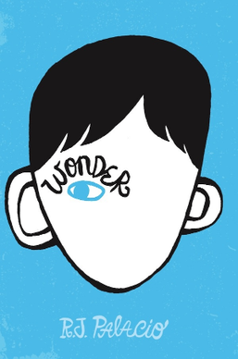
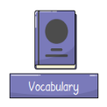
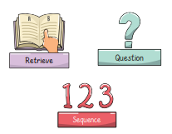
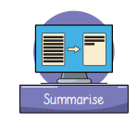
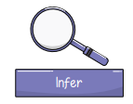

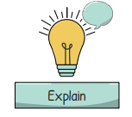
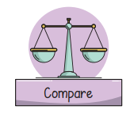
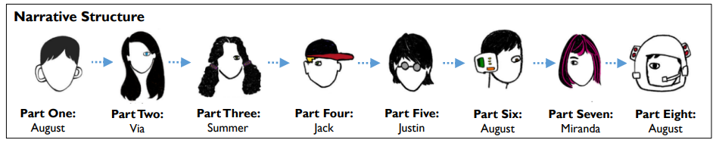
What inspired RJ Palacio to write Wonder?
I was with my two sons one day in front of an ice cream store, and we found ourselves in close proximity to a child with a severe facial difference. My younger son started to cry because he was scared, and I was nervous that his tears might hurt the child’s feelings, so I left the scene very quickly and rather abruptly. I realised afterwards that I had handled the situation terribly. It made me wonder what it must be like for that child, facing a world every day that doesn’t know how to face you back.
Themes
Difference Empathy Compassion Acceptance
Friendship Kindness Prejudice
Setting
Wonder is set in the continent of North America in suburban New York.
Plot summary
August (Auggie) Pullman was born with a severe facial difference that, up until now, has prevented him from going to a mainstream school.
Starting 5th grade at Beecher Prep, Auggie wants nothing more than to be treated as an ordinary kid but his new classmates can’t get past his extraordinary face. Wonder begins from Auggie’s point of view, but soon switches to include the perspectives of his classmates, his sister, her boyfriend and others.
‘Why blend in when you were born to stand out?’
Wonder
By R.J. Palacio
Key Characters
- August (Auggie)– the protagonist who has had twenty-seven surgeries and has some medical mysteries that doctors still haven’t figured out.
- Via (Olivia) – Via is Auggie’s sister and a freshman at Faulkner High School. She sometimes feels in Auggie’s shadow.
- Julian – the lead antagonist, Julian Albans is one of Auggie’s biggest obstacles at Beecher Prep.
- Jack Will, Summer and Charlotte – Some of Auggie’s first and dearest friends at Beecher Prep.

