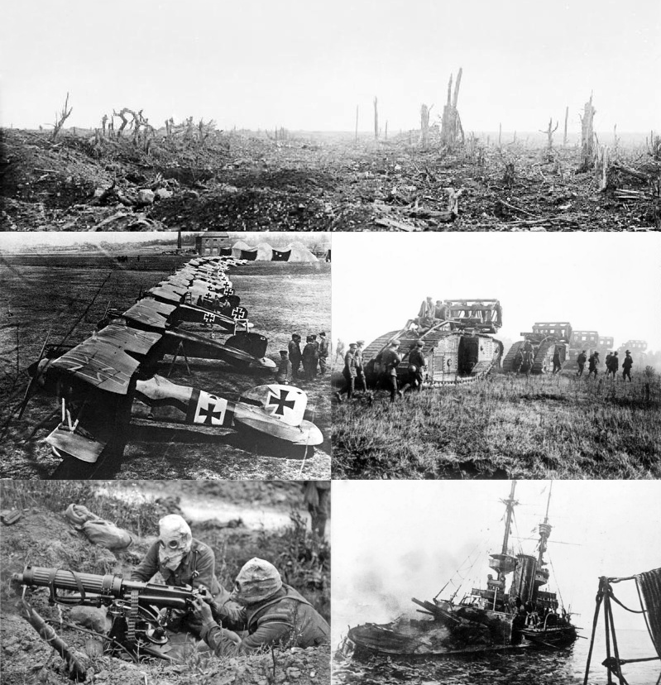
World War I
Vocabulary Check
Underline in:
Green - Words you know and understand.
Orange - Words you think you understand a little but need to know more.
Red - Words you don’t understand.

imperialism alliance mechanised warfare chemical warfare trench warfare
No Man’s Land
Home Front conscription armistice

