
Firfield Primary School - Leave Of Absence Request Form
The Department For Education released some new guidance to be in place from September 2024: Working together to improve school attendance - GOV.UK (www.gov.uk). This clearly states pupils should not be taken out of school during term time unless it is unavoidable. Further information about this is on the back of this form. Please read this and consider the implications BEFORE submitting any request for leave of absence.
IF THE REQUEST IS FOR A FAMILY HOLIDAY PLEASE SUBMIT IT BEFORE THE HOLIDAY IS BOOKED.
____________________________________________________________________________________________________________________________
Name of Child(ren): Class:
____________________________________________________________________________________________________________________________

Address: ________________________________________________________________________
Name of applicant(s): _____________________________________________________________
I/ we wish to apply for our child(ren) to be absent from school for EXCEPTIONAL CIRCUMSTANCES on the following dates:
From: _________________________ To: ____________________________
Total Number of school days absence: _______________________________________________
Please supply in as much detail as possible about the reason for your request and why you feel there are exceptional circumstances/ why this leave should be approved.
Include the names of the adult(s) who will be with your child(ren) during their absence.
The Department for Education does not consider a need or desire for a holiday or other absence for the purpose of leisure and recreation to be an exceptional circumstance.

I have read and understood the information detailed overleaf
Signed ___________________________________________ Print name ________________________
Date ________________________________
Office use only: | Attendance to date: |  | Attendance last year: |  | Term time leave in last 3 years:
Office use only: | Authorised |  | Fine: |  | NFA and reason:

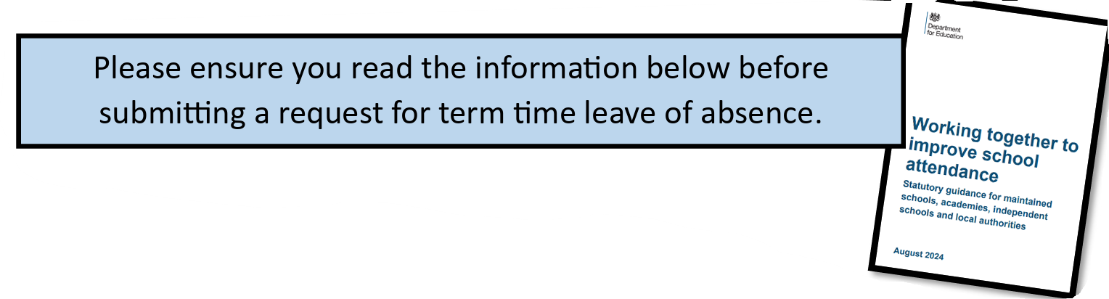

The Government states that:
- Pupils should not be taken out of school during term time unless it is unavoidable
- Schools are required to consider requests for leave of absence in term time and should only approve the leave if there are exceptional circumstances.
- If a request for leave is denied and the pupil is absent for 5 days or more then the school is expected to refer the case to the LA.
- The LA will issue a penalty notice with no requirement for a formal warning to be issued.
- Penalty notices can also be issued where a pupil is absent for repeated incidents of unauthorised leave in term time that fall below the 5-day threshold. In every case, the request for the Penalty Notice comes in from the school to the LA for the process to be completed.

It is important to note that:
If this request for leave of absence is NOT agreed and this is 5 days or more then a fine of £160 per parent (reduced to £80 if paid within 21 days) will be issued.
If this period of absence is below 5 days, a fine will not be issued unless there have been previous incidents of unauthorised absence (no reason given for absence, late after registers close at 9.05am, absence for another reason that is unauthorised) totalling more than 5 days of absence. If this is the case, a fine will be issued.
Schools are now required to keep records over a rolling 3 year period
- If a second fine is issued within 3 years, then the amount of the fine is increased to £160 with no reduction for early payment.
- If there is a third occurrence within 3 years, it is likely the case will be presented to the Magistrates’ Court

We are unable to accept additional information to justify absences exceeding 5 days, such as delayed flight, unless this is backed up by strong evidence eg email from airline etc
The Department for Education does not consider a need or desire for a holiday or other absence for the purpose of leisure and recreation to be an exceptional circumstance.

