
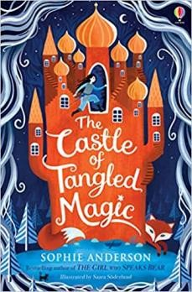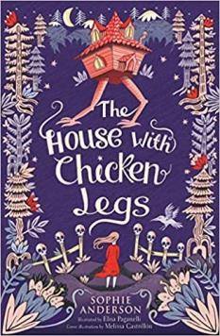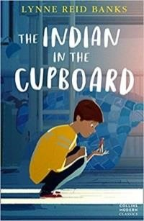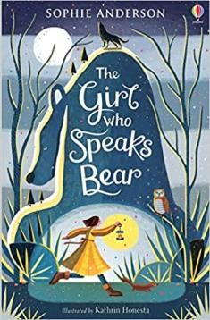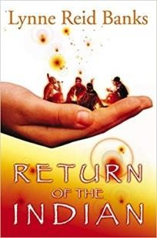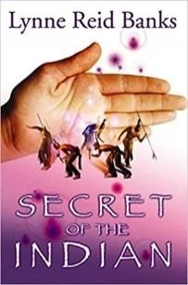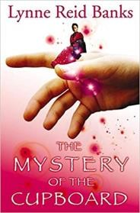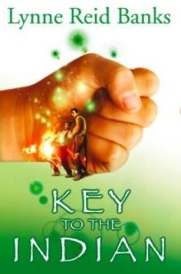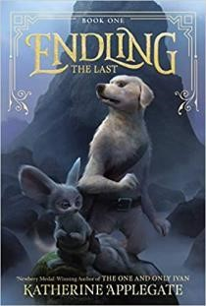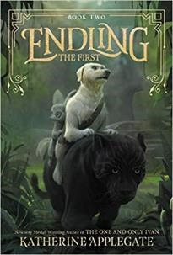

Year 5

Recommended Series

List

Anderson, Sophie

Anderson Fairy Tales

Though the three books are not a
series, they are 3 fairy tale style novels
from the Best Selling
Author

Sophie
Anderson
.

The Girl Who Speaks Bear)
(
Found
abandoned in a bear cave as a baby, Yanka
has always wondered about where she is
from. She tries to ignore the strange
whispers and looks from the villagers,
wishing she was as strong on the inside as
she is on the outside.

But, when she has to
flee her house, looking for answers about
who she really is, a journey far beyond one
that she ever imagined begins: from icy
rivers to smouldering mountains meeting
an ever
-
growing herd of extraordinary
friends along the way.

Ap
plegate,
Katherine

Endling

)
BRIO
(

Byx is the youngest member of her
dairne pack. Believed to possess
remarkable abilities, her mythical
doglike species has been hunted to
near extinction in the war
-
torn
kingdom of Nedarra

After her pack is
hunted down and killed, Byx fears she
may be the last of her species. The
Endling. So Byx sets out to find safe
haven, and to see if the legends of
other hidden dairnes are true.

Banks, Lynne Reid

The Indian in the
Cupboard

(
BRIO
)

The Indian in the Cupboard is the first
of five gripping books about Omri and
his plastic North American Indian
–

Little Bull
–

who comes alive when
Omri puts him in a cupboard. For
Omri, it is a dream come true when
the plastic American Indian he locks
in
to the old cupboard comes to life.
Little Bull is everything an Indian
brave should be
–

proud, fearless and
defiant.

BRIO

–

Best
Read I
n Order

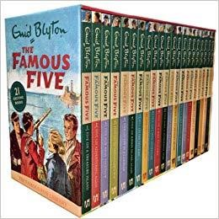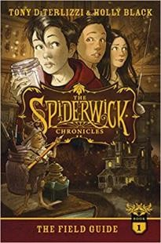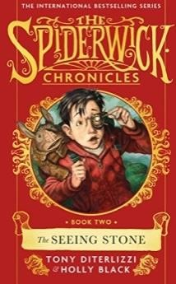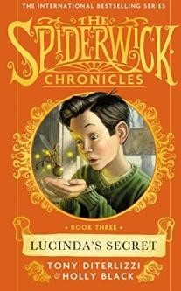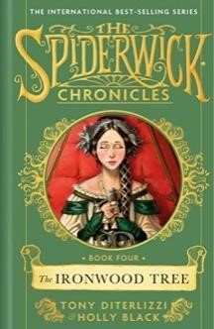
Black, Holly

Spiderwick Chronicles
(
BRIO)

It all started when Jared Grace found
their great uncle's book, "Arthur
Spiderwick's

Field Guide to the
Fantastic World Around You." and
they realise that are not alone in their
new house. Now the Grace kids want
to tell their story but the faeries will
do everything to stop them...

Blyton, Enid

Famous Five Series

Julian, Dick,
Anne, George and Timmy
the dog find excitement and
adventure wherever they go in Enid
Blyton's most popular series.

Meet the Famous Five and encounter
smugglers, thieves, runaways and
other strange and mysterious people
-

both good and bad.

exci
21
ting adventures: Five on A Treasure Island, Five Go
Adventuring Again, Five Run Away Together, Five Go To
Smuggler's Top, Five Go Off In A Caravan, Five On Kirrin Island
Again, Five Go Off To Camp, Five Get Into Trouble, Five Fall
Into Adventure, Five On A

Hike Together, Five Have A
Wonderful Time, Five Go Down To The Sea; Five Go To Mystery
Moor, Five Have Plenty Of Fun; Five On A Secret Trail, Five Go
To Billycock Hill, Five Get Into A Fix, Five On Finniston Farm,
Five Go To Demon's Rocks, Five Have A Mys
tery To Solve, Five
Are Together Again

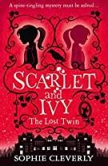
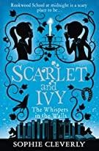
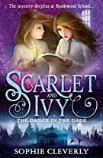
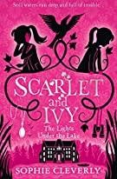
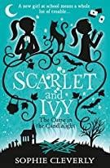
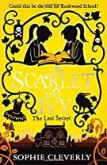
Blyton, Enid | St Clare’s (BRIO)  Schooldays at St Clare's are never dull for twins Pat and Isabel O'Sullivan in Enid Blyton's muchloved boarding school series. |  | 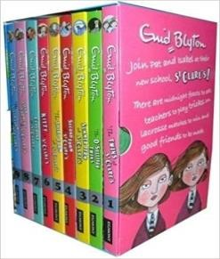 | The Twins At St Clare's, The O' Sullivan Twins, Summer Term At St  Clare's, Second From At St Clare's, The Third From At St Clare's, Kittty At St Clare's, Claudin At St Clare's, Fifth Formers At St Clare's and The Sixth From At St Clare's
Cleverly, Sophie Scarlett and Ivy _{(BRIO)}

This is the story of how I became my sister…

A spine-tingling mystery set in a
creepily atmospheric boarding school.
Ivy must uncover the secrets behind her twin sister Scarlet’s disappearance before it’s too late.

Cowell, Cressida | 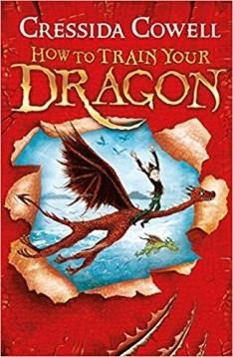  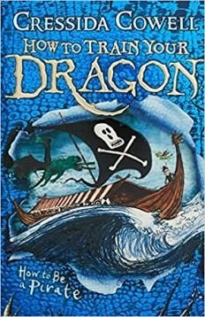  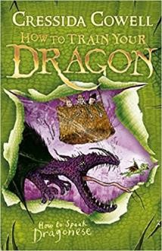  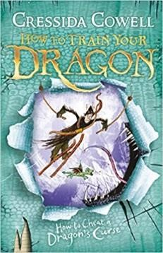  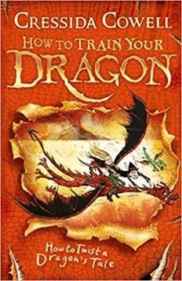  How to Train your  Dragon (_{BRIO)}  Hiccup Horrendous Haddock the Third is a smallish Viking with a longish name. Hiccup's father is chief of the Hairy Hooligan tribe which means  Hiccup is the Hope and the Heir to the Hairy Hooligan throne - but most of the time Hiccup feels like a very ordinary boy, finding it hard to be a Hero.
Cowell, Cressida |  | …and ma  more title | ny  s.
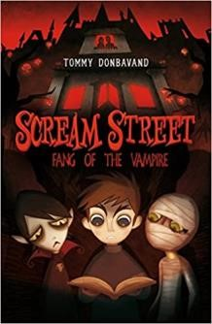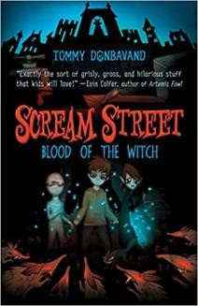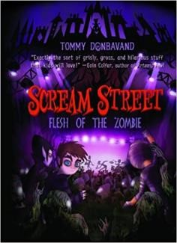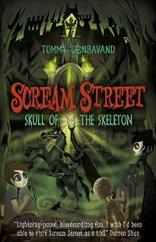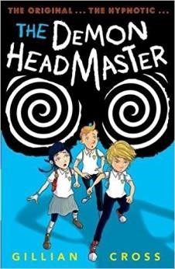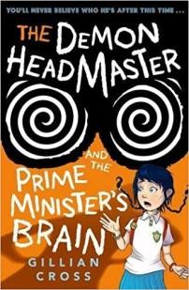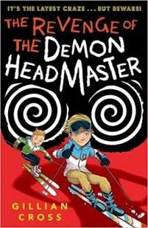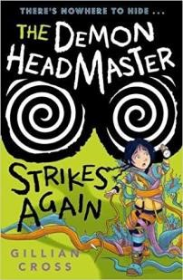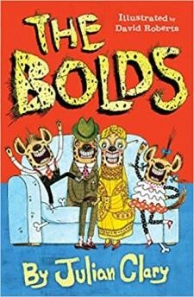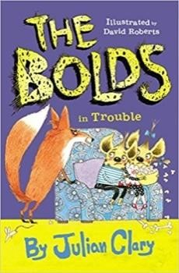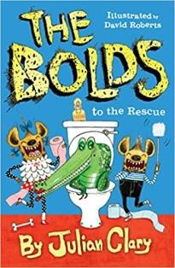
Clary, Julian

The Bolds

The Bolds are just like you and me:
they live in a nice house, they have
jobs and they love to have a bit of a
giggle. One slight difference: they are
hyenas.

Cross, Gillian

Daemon Headmaster

(
BRIO)

When Dinah is fostered
by the Hunters
she thinks her biggest problem will be
fitting in with her foster
-
brothers,
Lloyd and Harvey. However, once she
starts at her new school it's clear that
there's more to worry about. All the
children, apart from a handful
including Lloyd and
Harvey, are too
well
-
behaved
-

robotic almost
-

and
oddly keen to please the creepy
headmaster.

Donbavand,
Tommy

Scream Street

In Scream Street, Luke and his
parents discover a nightmarish
world of the undead. Luke soon
makes friends with vampire Resus
Negative and mummy Cleo Farr,
but he remains determined to
take his terrified parents home.

…and many more
titles.

…and many more titles.

…and many more titles.

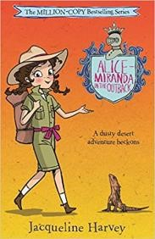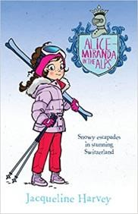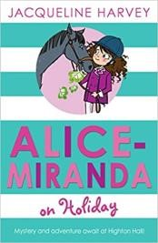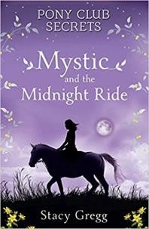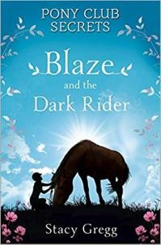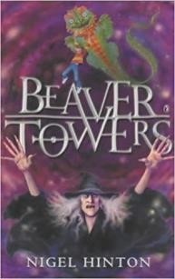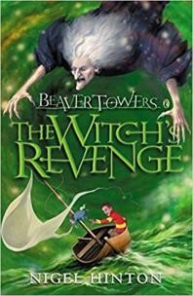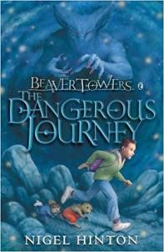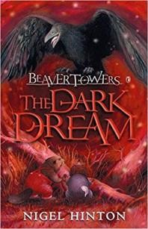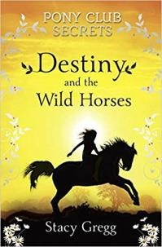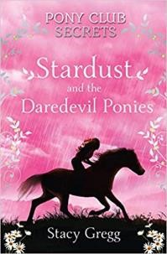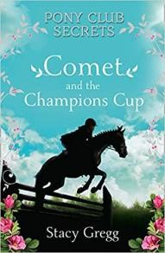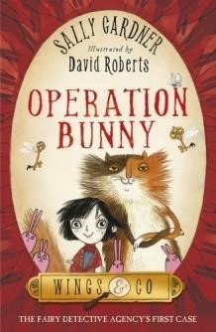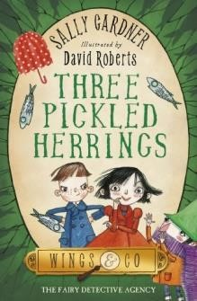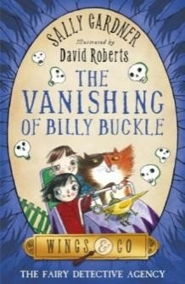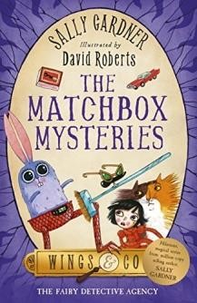
Gardner, Sally

Wings and Co

Emily Vole makes headline news in the first
weeks of her life, when she is found in an
abandoned hatbox in Stansted Airport.

Then, only a few years later, her neighbour
Mrs String dies leaving Emily a mysterious
inheritance: an

old shop, a small bunch of
golden keys and a cat called Fidget. It's the
beginning of an adventure of a lifetime as
the old Fairy Detective Agency comes back
to life.

Gregg, Stacy

Pony Club Secrets

Issie loves horses more than anything!

And she especially loves her pony
Mystic at Chevalier Point Pony Club.
So when the unthinkable happens,
Issie is devastated.

Harvery, Jacqueline

Alice
-
Miranda

Alice
-
Miranda and her friends
are heading into the
Australian outback for a desert
adventure. What mysteries
will they stumble upon?

Hinton, Nigel

Beaver Towers Series

(
BRIO)

A magic spell whisks Philip away on
his new kite to a far
-
off island where
he meets the beavers
-

Mr Edgar and
his grandson, Baby B. They tell him of
the terrible danger that threatens
them. The wicked witch Oyin has
imprisoned most of the island's
inhabit
ants in Beaver Towers, and
when her powers are complete she
will put them to death and rule the
island. Philip has to get her spell book
in order to save them.

…and many

more titles.

…and more titles.

…and more titles.

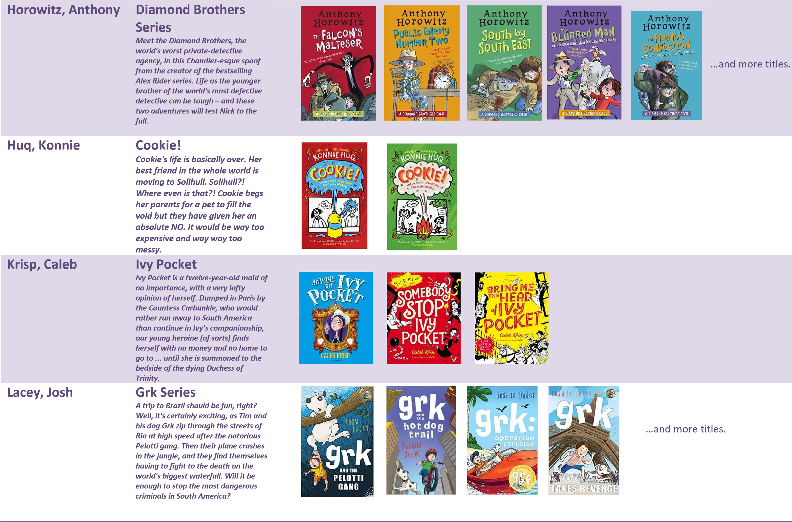
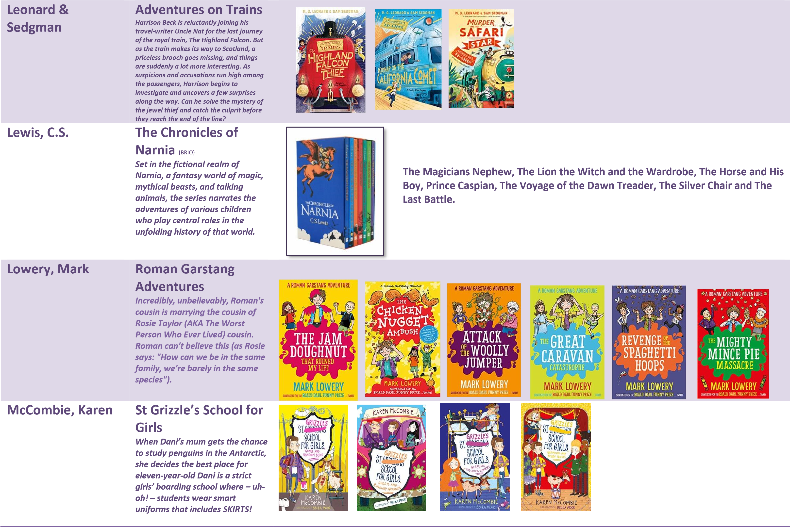
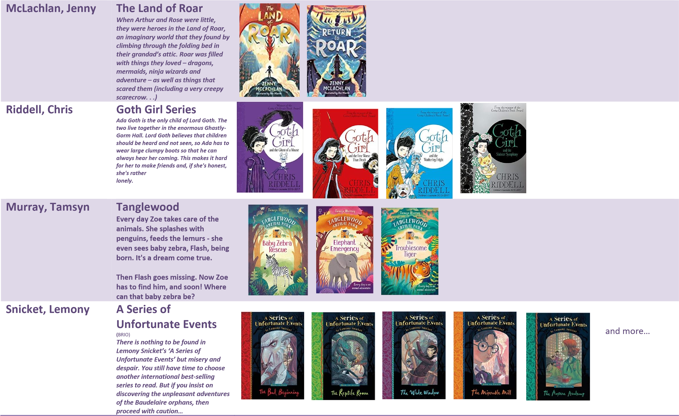
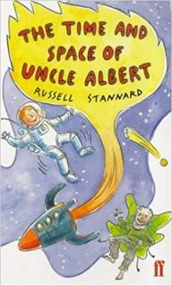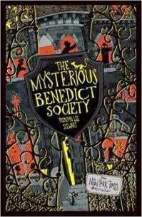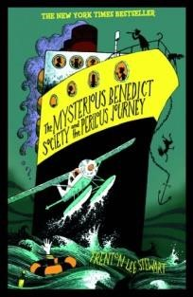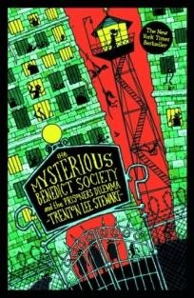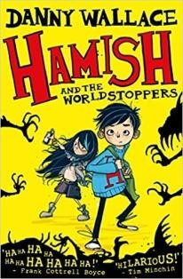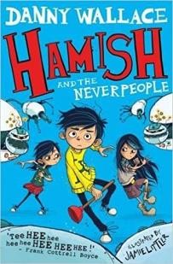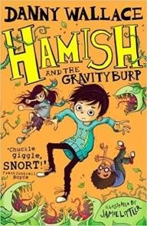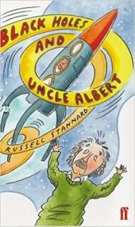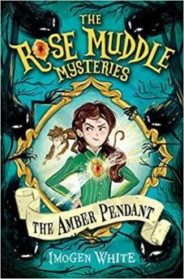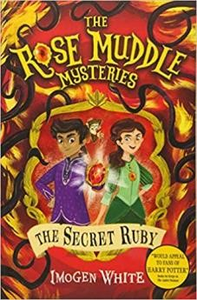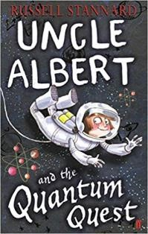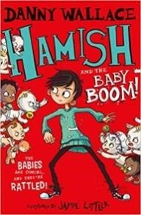
Stannard, Russell

Uncle Albert
Series

Uncle Albert, the famous scientist, has
got stuck. To unlock the deep
mysteries of space and time someone
must agree to be beamed up into the
unknown world of the thought bubble.
His brave niece, Gadanken, decides to
risk it. So begin her exciting a
nd
astonishing adventures.

Steward, Trenton
Lee

The Mysterious
Benedict Society

(
BRIO)

When a peculiar advertisement
appears in the newspaper for
children to take part in a secret
mission, children everywhere sit a
serie
s of mysterious test. In
the
end
, just four children
succeed
.

Danny Wallace

Hamish Series

Because that's what keeps happening
to ten
-
year
-
old Hamish Ellerby.

And it's being caused by The
WorldStoppers and their terrifying
friends The Terribles! They have a
PLAN! They want
to take our world for
their own . . . Oh, and they hate
children. Especially if you're a child
who knows about them.

White, Imogen

Rose Muddle
Mysteries

When Rose Muddle is plucked
from the workhouse to become a
maid in a grand mansion, she
discovers that her new mistress
has secret plans for her
-

plans
which involve a strange amber
pendant with extraordinary
powers.

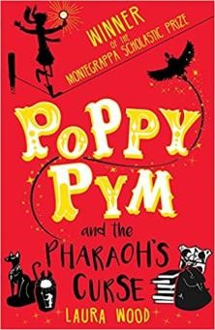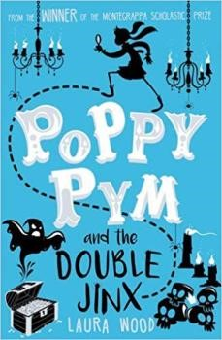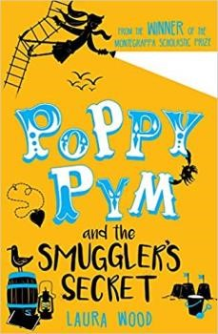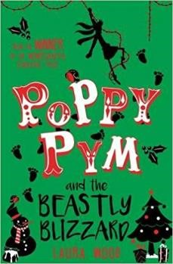
Wood, Laura

Poppy Pym

(
_{BRIO)}

Poppy Pym has grown up in the
circus, taming lions before lunch
and learning acrobatics in
the
afternoon. But when she turns
eleven, her circus family decides
she needs a more traditional
education, and she is sent to
boarding school.

