
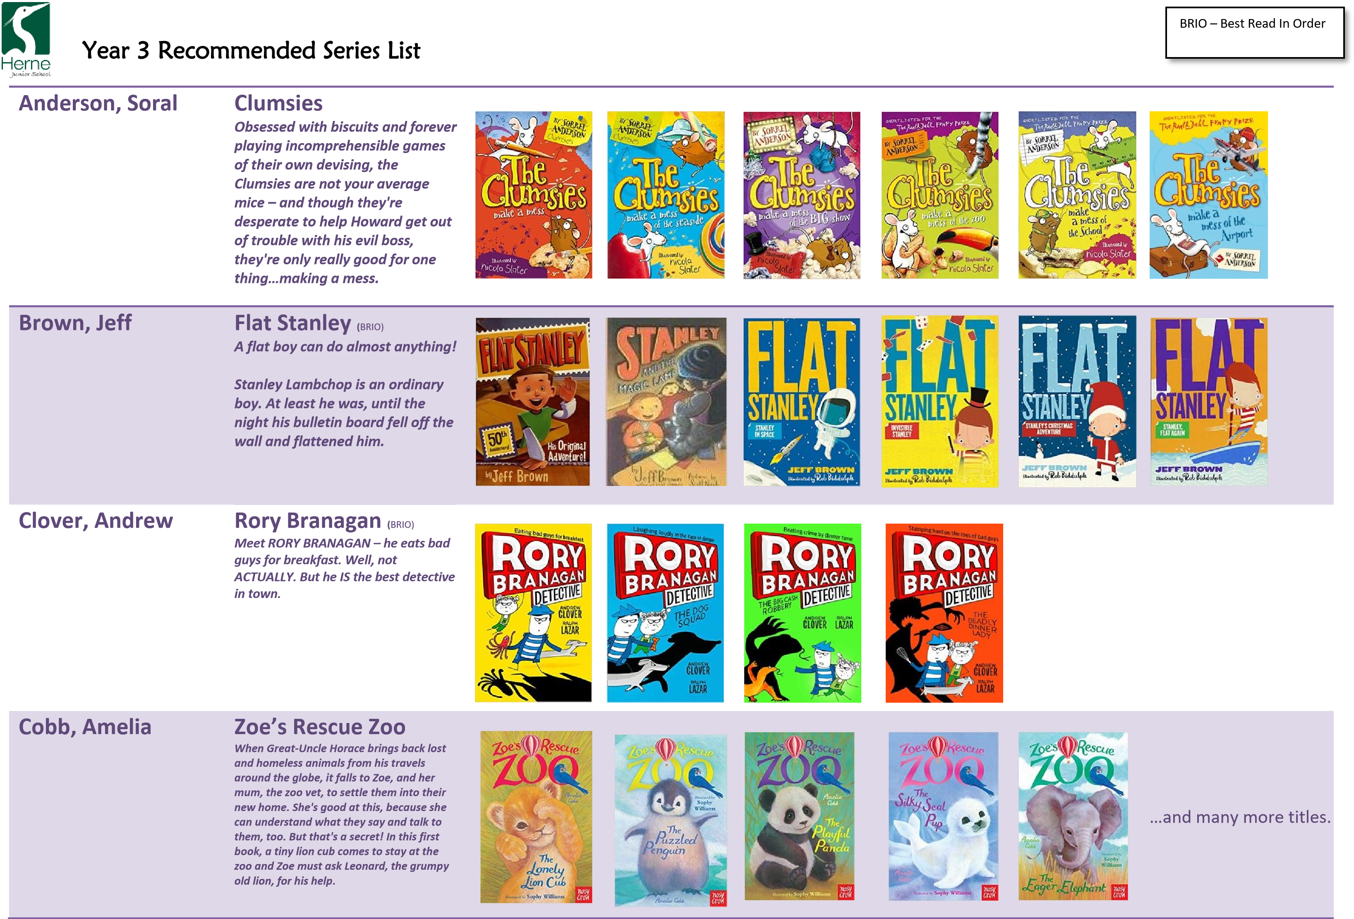
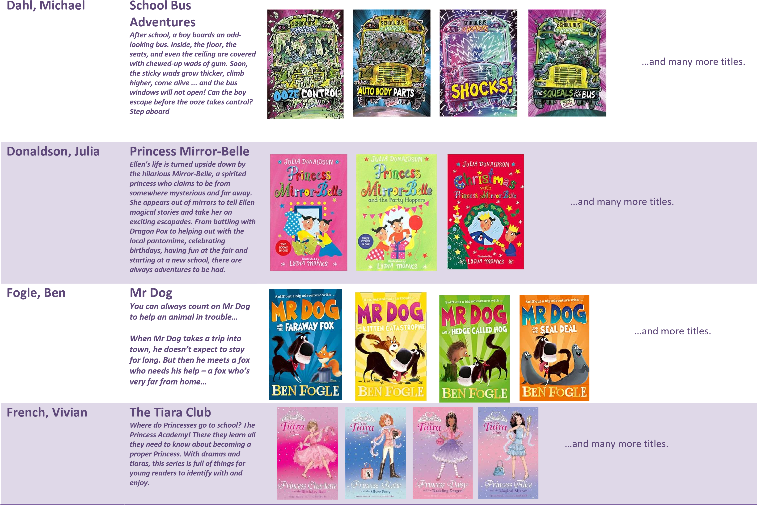
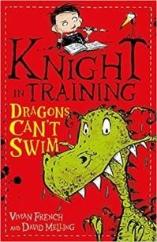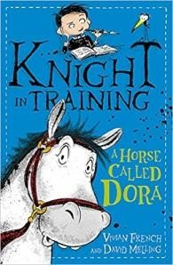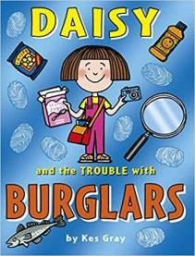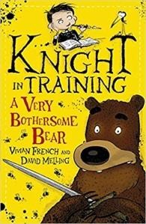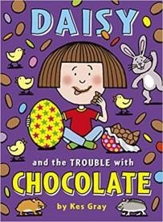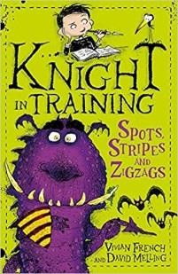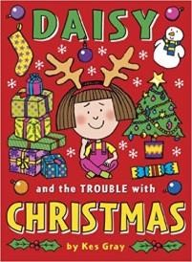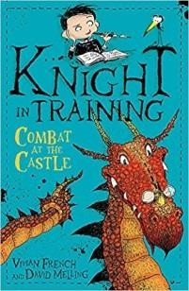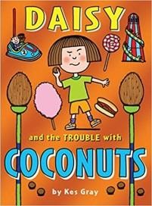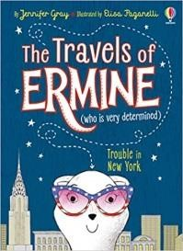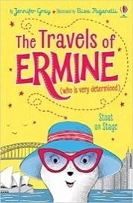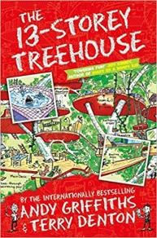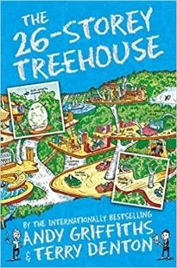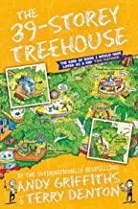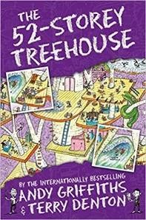
French & Melling

Knight

in Training

Sam J. Butterbiggins' only ambition is to be
a Very Noble Knight, but he has a problem
-

he's been packed off to the castle next door

to stay with his aunt and uncle while his
parents are away. Not only does he have to
put up with his annoying cousin Prune,
there are also the weird creatures his aunt
looks after in her Luxury Accommodation
for Dragons, Griffins and other Regal Beasts
to

contend with!

Gray, Jennifer

Travels of Ermine

Meet Ermine. She may be small but
she's on a BIG journey around the
world. Ermine the Determined is off to
explore New York! She can't wait to
visit Central Park Zoo, ride in a yellow
taxi, and zoom

to the top of the
Rockefeller building! But when her
suitcase is switched, Ermine finds
some robbers are hot on her tail...

Gray, Kes

Daisy

When three actual burglaries happen
in Daisy’s town, Daisy is beside herself
with excitement. Two houses and
the
fish and chip shop have been broken
into (and lots of cods and haddocks
have been stolen). Anyone could be
next!

Griffiths, Andy

The Tree House Books

Andy and Terry live in the WORLD'S
BEST treehouse! It's got a giant
catapult, a secret underground
laboratory, a tank of man
-
eating
sharks and a marshmallow machine
that follows you around and shoots
marshmallows into your mouth
whenever you're hungry. . Oh, and,
whatever you do, don't get trapped in
a burp
-
gas
-
filled bubb
le . . . !

…and many more titles.

… and more titles.

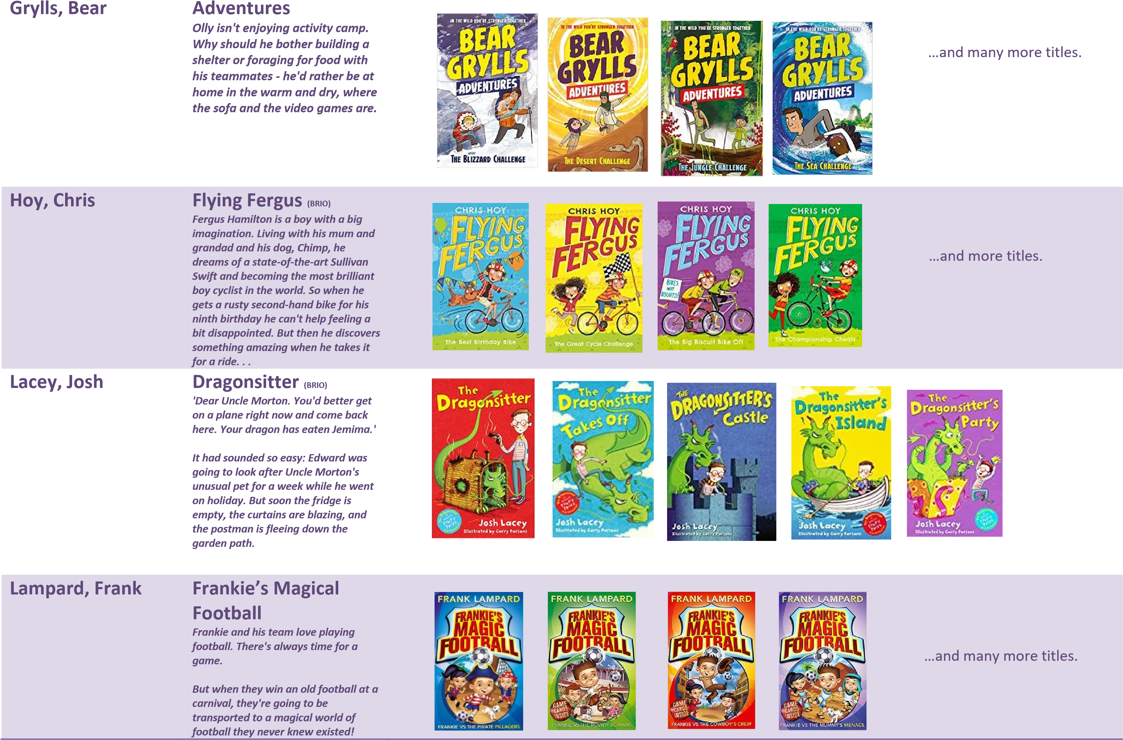
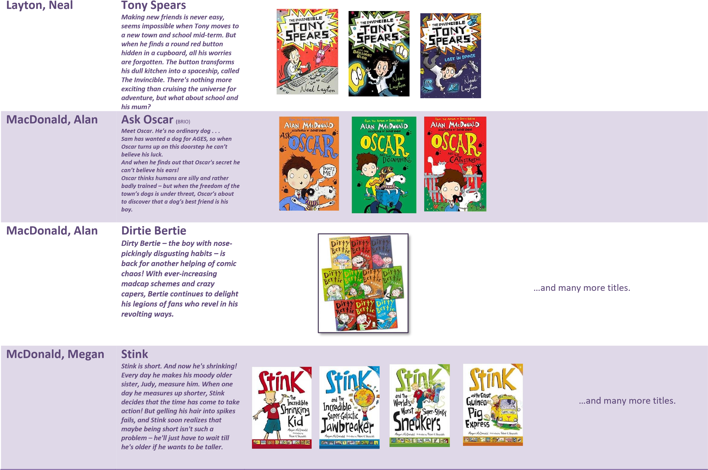
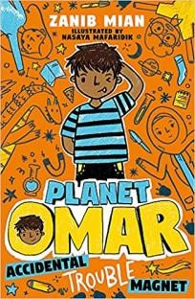
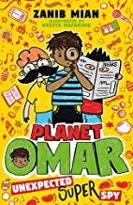


Mian, Zanib Planet Omar (_{BRIO)}
My parents decided it would be a good idea to move house AND move me to a new school at the same time. As if I didn't have a hard enough time staying out of trouble at home, now I've also got to try and make new friends. What's worse, the class bully seems to think I'm the perfect target.

At least Eid's around the corner which means a feast (YAY) and presents (DOUBLE YAY). Well, as long as I can
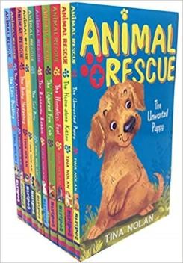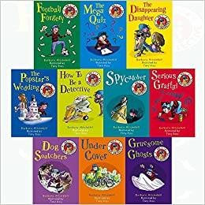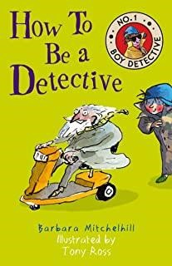
stay in Mum and Dad's good books
long enough...

Michelhill, Barbara

The Number 1 Boy
Detective

Collection

Damian thinks it's time to pass on
his amazing detective skills. On an
outing ot the library to teach his
eager trainees how to look for
criminals, they hit the jackpot: a
suspicious
-
looking lady who is
checking out a book called Loot.
But what

will happen when the
kids try to apprehend their
suspect?

Nolan, Tina

Animal
Rescue

Eva and Karl Harrison live at the
Animal Magic Rescue Centre with their
parents and have to help a new arrival
recover every single day. They have to
deal with a
ginger kitten who's been
locked out of their football star
owner's house; find a new home for a
loveable puppy; and nurse an injured
fox cub back to health.

…and many more titles.

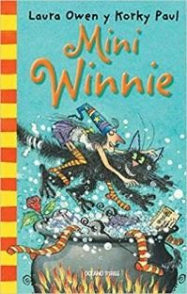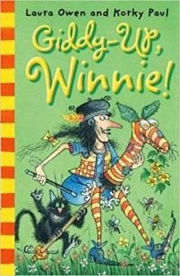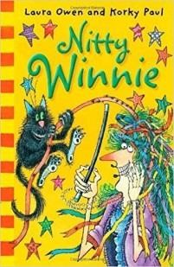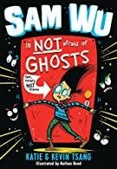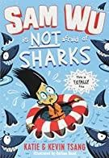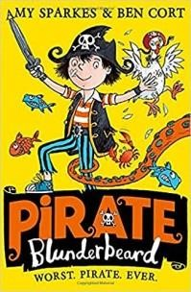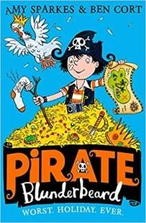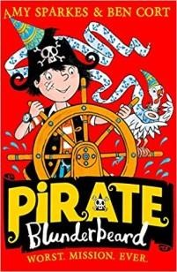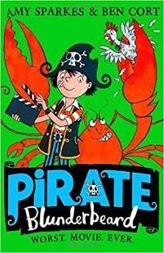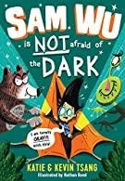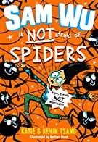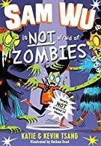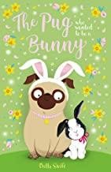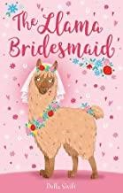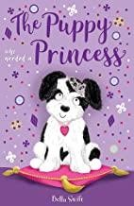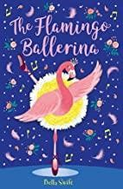
Owen, Laura

Winnie the Witch

Winnie shares her big black house
with
Wilbur her big black cat. So
sometimes she accidentally trips over
him. Ouch! After some spells that
make Wilbur look very silly, Winnie
finds just the right magic to make sure
she can always see him.

Sparkes, Amy

Pirate Plunderbeard

Mum is making me take part in the stupid
Pirate of the Year Award. All I have to do is
fight an enormous sea monster, (doom),
beat my oh
-
so
-
brilliant brother at
something (please please

please) and find
the legendary treasure that no one has ever
found EVER in the history of EVER (easy
peasy, then). Wish me luck! Pirate
Blunderbeard.

Swift, Bella

The Animal Collection

(
First in the collection)
The Pug Who
Wanted to Be a Bunny:

Peggy the pug's family have adopted
an adorable little bunny, just in time
for Easter. Peggy used to be top dog,
but now she has to share their
attention with this long
-
eared
newcomer. Jealous of the new pet,
Peggy decides that she must become a
rabbit to

compete.

Tsang, Katie &
Kevin

Sam Wu is not afraid
of…..

Sam Wu is NOT a scaredy
-
cat
except he is). When a trip to
(
the Space Museum goes
terrifyingly wrong, Sam begins
a mission to prove to the
school bully, and all of his

friends, that he is a fearless
space adventurer.

…and many more titles.

Also ‘Winnie and
Wilbur’ books.

…and many more titles.

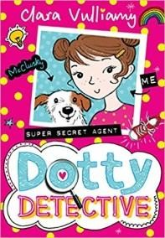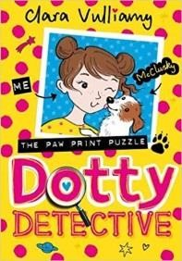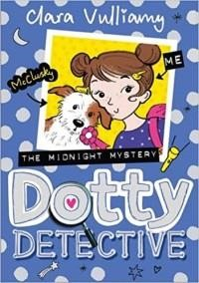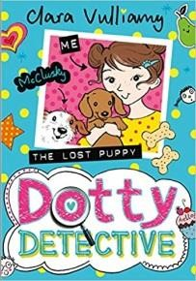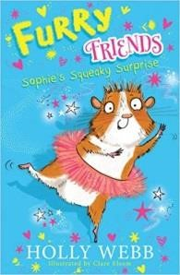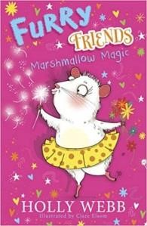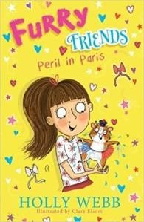
Vulliamy, Clara

Dotty Detective

Dot loves super
-
sour apple sherberts,
running fast and puzzles
–

especially if
they’re fiendishly tricky. And with the
help of trusty sidekick, Beans and TOP
DOG,
McClusky, she is always ready to
sniff out a mystery. So when meangirl
Laura seems set on sabotaging the
school talent show, Dot is determined
to find out how, and save the day…

Webb, Holly

Furry Friends
(
BRIO)

Sophie
isn't happy about moving to a
strange new country and starting at a
new school. But then she meets
Josephine
-

a macaroon
-
eating, tutu
-
wearing guinea pig, who lives with her
furry friends in the centre of Paris.
Josephine soon shows Sophie that
living in a

new place is exciting and
being friends with a guinea pig is the
best adventure of all.

…and many more titles.

