Key Vocabulary
auction | Public sale in which goods/property are sold to the highest bidder.
barren | Land too poor to produce much or any vegetables/crops.
calloused | Having an area of hardened skin.
contritely | Feeling regret and sorrow for one’s sins or offences.
counsellor | A person trained to give guidance on personal or psychological problems.
descendant | A person that is descended from a particular ancestor.
desolate | Uninhabited and giving an impression of bleak emptiness.
incarcerate | Imprison or confine
juvenile | For or relating to young people
mirage | An optical illusion caused by atmospheric conditions.
miscarriage | An unsuccessful outcomes of something planned.
precipice | A very steep rock face or cliff.
shrivelled | Withered, as with a loss of moisture
spigot | A small peg or plug.
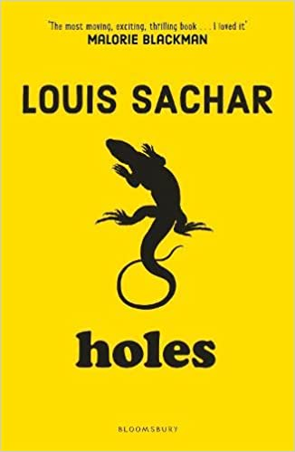
Context
The narrator of Holes seems reliable but often interjects dark humour or irony into the narration. Many statements are made which require the reader to make his or her own inferences about the subject matter. At times, the narrator breaks with the omniscient narration to address the reader directly and pose questions about the events in the book. The text shows the importance of friendship and in contrast the consequences of cruelty and bullying with the use of dark humour and irony.
Key Quotes
‘A lot of people don’t believe in curses. A lot of people don’t believe in yellow-spotted lizards either, but if one bites you, it doesn’t make a difference whether you believe in it or not.”
“His muscles and hands weren’t the only parts of his body that had toughened over the past several weeks. His heart had hardened as well.”
“If you take a bad boy and make him dig a hole every day in the hot sun, it will turn him into a good boy.”
Key Characters
Stanley Yelnats – The novel’s protagonist – convicted of a crime he didn’t commit.
Zero – Another boy at Camp Green Lake who becomes close friends with Stanley.
X-Ray – Takes charge of the boys at camp and is friendly to Stanley.
Squid – Often taunts Stanley about writing letters to his mother.
Magnet – Earned his nickname by his ability to steal things.
Armpit – Pushes Stanley to the floor when he forgets to call him by his nickname.
Zigzag – Stanley thinks that Zigzag is the weirdest kid at Camp Green Lake.
Warden – The ultimate symbol of cruel authority at Camp Green Lake.
Mr Pendanski – In charge of Tent D – Stanley’s tent at the camp.

Themes
Fate and free will, justice and judgement, choices, friendship and morality.

Plot summary
Stanley Yelnats is under a curse. A curse that begins with his no-good-dirty-rotten-pig-stealing-great-great-grandfather. Now, Stanley has been unjustly sent to a juvenile detention centre, Camp Green Lake, where the boys build character by spending all day, every day digging holes exactly five feet deep. It doesn’t take long for Stanley to realise there’s more than character improvement going on there.
Holes
By Louis Sachar
D – Decode
E – Explain
R – Retrieval
I – Inference
C – Word Choice

