Key Vocabulary
amulet | A piece of jewellery thought to protect against evil or danger.
billboard | A large outdoor board for displaying adverts.
boulevard | A large road.
grating | A harsh sound
gunpowder | A type of powdered explosive used in fireworks.
idleness | Being lazy
incandescent | Something that gives off light as a result of being heated.
jeer | To make rude or mocking remarks
lotus | A type of flower
pyrotechnics | Another word for a firework display.
rickshaw | This is a two wheeled passenger vehicle that is pulled by a person. Similar to a cart that people can sit in the back of.
roosting | A place where birds settle down for the night.
Rupee | The official currency of India
sarong | Long piece of cloth wrapped round the body and tucked at the waist.
steamed | A group of people moving in the same direction, continuously.
sulphur | A yellow non-metal material with explosive qualities
toiled | To have worked hard.
trundled | To walk heavily or slowly.
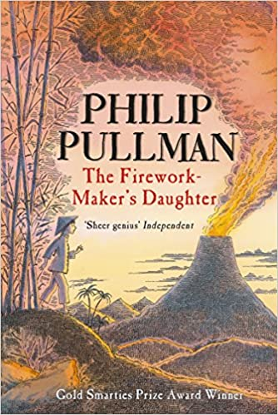
Context
Pullman originally wrote the story as a school play. However, it became a best-selling book first and was then adapted into a play. Called a ‘fairy tale’ by Pullman, the story is both a children’s adventure story where the main character undertakes a quest to prove herself, and a metaphor for making beautiful art. In 2015, Pullman said, “I think there is a place for magic in the world – and it’s in stories. We’d be a lot poorer, imaginatively, and possibly emotionally, it we cut out all the magic.”
Key Characters
Lila – Protagonist – The daughter of Lalchland who learned to make her own fireworks and dreams of becoming a firework-maker herself.
Lalchland – Lila’s father who taught her how to make fireworks but now wants her to find a husband instead. His wife, and Lila’s mother, died when Lila was young.
Razvani – Antagonist - The Fire Fiend on Mount Merapi.
Hamlet – A talking white elephant owned by the king.
Chulak – Hamlet’s servant who is also friends with Lila.
Jembavati – Lalchland’s sister who would have brought Lila up as a dancer.

Themes
The main themes are humour, good versus evil, traditions, teamwork, greed, poverty.
Key Quotes
‘So Lila said no more about being a Firework Maker and Lachland said no more about husbands.’
‘You had to put love into your fireworks.’

Plot summary
Lila doesn’t just want to be a Firework-Maker’s daughter; she wants to be a Firework Maker herself. But although she’s learned a lot she still must get through the most difficult and dangerous part of her apprenticeship – and her father won’t tell her what it is.
In search of this final Firework-Making secret, Lila heads off alone on a journey. It is a journey filled with dangers beyond anything she could have imagined, a journey on which she will learn so much more than the one secret she set out to find . . .

D – Decode
E – Explain
R – Retrieval
I – Inference
C – Word Choice
The Firework Maker’s Daughter
By Philip Pullman

