Hedgehog Facts
Size | Length 20-30cm
Weight | Average 700g
Life-span | Can live up to 6 years
Species | Globally, there are 14 different species
Habitat | Mainly woodland habitats, hedgerows, fields, parks, towns and country gardens
Food | Slugs, snails, caterpillars, beetles, earthworms, birds’ eggs, sometimes frogs and snakes
Threats | Road traffic, habitat loss, garden chemicals, drowning, cattle grids, hibernation issues etc.
Did you know? | They have around 7000 spines which are replaced every year.
Key Vocabulary
accustomed | Familiar with something, to be used to something
ambled | Walk or move at a slow, relaxed pace.
attempts | Tries to complete something
chaos | Complete confusion
chute  D – Decode  E – Explain  R – Retrieval  I – Inference  C – Word Choice | Narrow tube or passage
commanded | Gave an order
concealed | Hidden from sight
confronted | To oppose or challenge
courtyard | An open space that is surrounded completely or partly by a building or group of buildings
nocturnal | Done, occurring or active at night
rush-hour | Rush hour is the part of the day during which the traffic on the roads is the busiest.
sidekick | Person who helps and spends a lot of time with someone.
tinker | Try to repair something
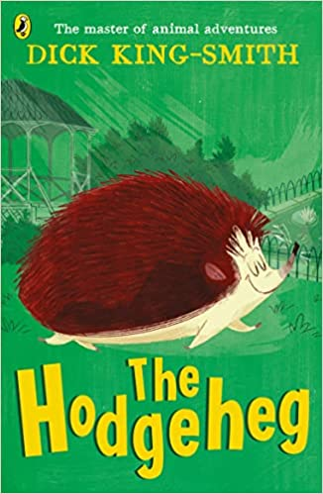
Context
Dick King-Smith was a Gloucestershire farmer until the age of 45, when he gave up farming to become a primary school teacher. Now a bestselling full-time author, his work has received many awards including a Bronze Medal for the Smarties Prize of 1997 for All Because of Jackson and the Children's Book Award in 1995 for Harriet's Hare. In 1992, he was also voted Children's Author of the Year. In 1995, his top-selling title The Sheep-Pig was developed into a box-office movie, BABE, introducing hundreds of thousands of youngsters to his work.
Characters
Max – a brave little hedgehog, who is determined to find a way across the busy road to get to the park.
Ma and Pa – Max’s parents
Uncle B – Max’s next door neighbour
Peony, Pansy & Petunia – Max’s sisters

Themes
We have chosen this book as it links in with many of our school values such as resilience… and it teaches a valuable lesson about road safety.
The Hodgeheg
By Dick King-Smith
Plot summary
Max is a hedgehog who lives with his family in a little home, but it’s on the wrong side of the road from the park where there’s a beautiful lily pond and plenty of delicious slugs, worms and snails. Despite the danger facing Max, he is determined to make his way across the busy road. If humans can do it, why can’t hedgehogs?
When he first tries to cross the road, it ends in a nasty bump on the head, and when Max tries to speak, he realised his words are all mixed up. He is no longer a hedgehog but a hodge-heg!
Still determined to fulfil his mission, Max discovers the best way to cross the road with the help of the lollipop lady and some careful detective work.

