Key Vocabulary
frightful | Very bad or unpleasant.
immediately | Without delay.
Labrador | A British breed of retriever gun dog.
mongrel | A mongrel is a dog which is a mixture of different breeds.
pedigree | If a dog, cat, or other animal has a pedigree, its ancestors are known and recorded. An animal is considered to have a good pedigree when all its known ancestors are of the same type.
shoo | If you shoo an animal or a person away, you make them go away by waving your hands or arms at them.
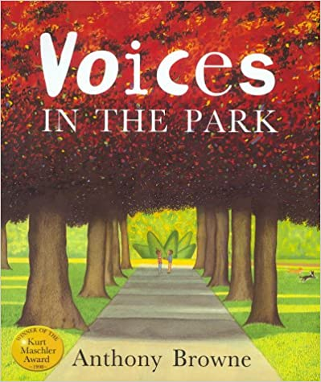
Voices in the park
By Anthony Browne
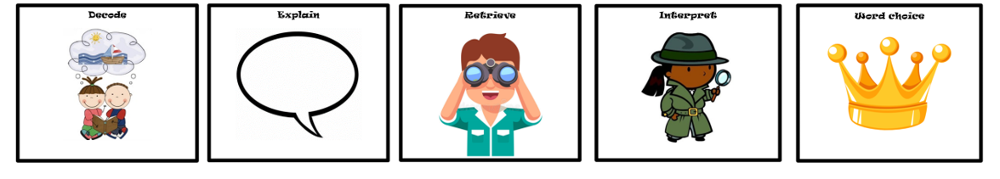
Plot summary
Four people go to the park, and through their eyes we see four different stories about what took place there. There’s the bossy woman, the sad man, the lonely boy – and the young girl whose warmth touches them all. As the story moves from one voice to another, their perspectives are reflected in the shifting landscapes and seasons.
D E R I C
Key Characters
Charles
Charles’ Mother
Smudge
Smudge’s Father

Themes
Anger Friendship Hope
Alienation

