Key Vocabulary
cider | An alcoholic drink made from fermented apple juice.
brutal | Very violent or unpleasant
colossal | Extremely large
delicately | In a very careful or gentle manner.
mechanical | Operated by a machine or machinery.
murky | Dark and gloomy
orchard | A piece of enclosed land planted with fruit trees.
prowling | Move quietly in search of prey
valley | A low area of land between hills or mountains, typically with a river or stream flowing through it.
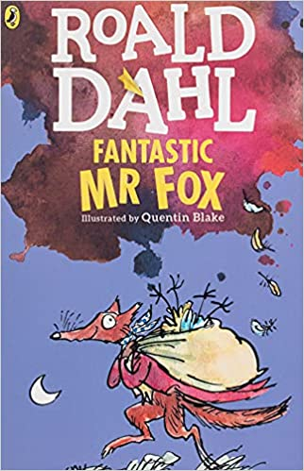
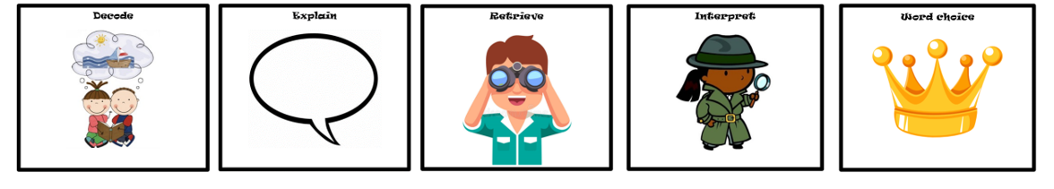
D E R I C
Context
Roald Dahl was born on 13th September 1916 in Wales. Fantastic Mr Fox was published in 1970 and in 2009, the book was made into a film.
The book is said to have been inspired by the ‘Witches’ tree, an old tree that grew close to his home. Dahl always used to tell his children that a family of foxes lived under the tree, in a hole beneath the trunk.
Key Characters
Mr Fox – Protagonist – Clever and brave fox who finds food for his family.
Mrs Fox – The kind and loyal wife of Mr Fox.
Boggis – Antagonist – A fat chicken farmer who eats three boiled chickens a day.
Bunce – Antagonist – A short duck-and-goose farmer who eats doughnuts and goose livers, giving him tummy ache and a temper.
Bean – Antagonist – A tall, thin turkey-and-apple farmer who drinks gallons of cider. The cleverest of the three.

Themes
The story is set in the countryside where farmers look after livestock or have orchards to tend to. The foxes live in burrows underground and have to dig further down to escape the farmers.
Some scene are set in the houses of the farmers.
Plot summary
When three mean farmers decide enough is enough and try to catch the fox which keeps stealing all their livestock, Mr Fox has to lead his family to safety and outwit the farmers to keep his family alive.
Fantastic Mr Fox
By Roald Dahl

