Key Vocabulary
appalling | Something that is appalling is so bad or unpleasant that it shocks you.
bell jar | A bell-shaped glass cover used to cover apparatus in experiments, and to prevent gases escaping.
commotion | A commotion is a lot of noise, confusion, and excitement.
lab | A lab or laboratory is a building or a room where scientific experiments, analyses, and research are carried out.
monstrous | If you describe an unpleasant thing as monstrous, you mean that it is extremely large in size or extent.
peered | If you peer at something, you look at it very hard, usually because it is difficult to see clearly.
prodded | To poke or jab with or as if with a pointed object.
recycled | If you recycle things that have already been used, such as bottles or sheets of paper, you process them so that they can be used again.
vent | A vent is a hole in something through which air can come in and smoke, gas, or smells can go out.
The Barnabus Project
By The Fan Brothers
Plot summary
Deep underground beneath Perfect Pets, where children can buy “perfect” creatures, there is a secret lab. Barnabus and his friends live in this lab, but none of them is perfect. They are all Failed Projects. But Barnabus dreams of freedom, and leads his misfit friends on a perilous adventure.

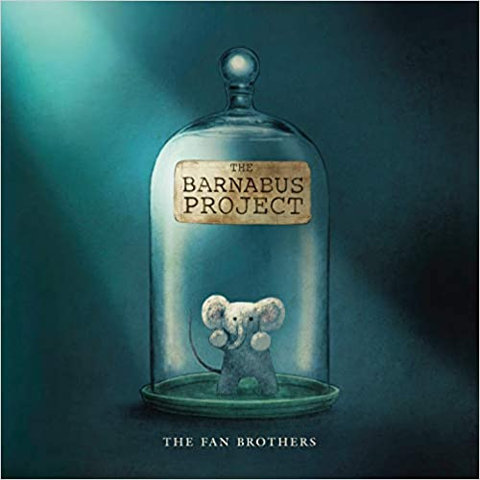
Themes
Perfection and failure, freedom, tolerance and acceptance.
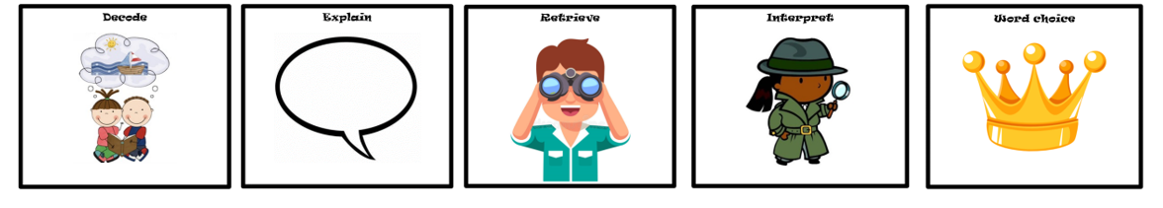
D E R I C

