Key Vocabulary
adapt | Make fit for, or change to suit a new purpose.
ancestor | Someone from whom you are related and directly descended from.
arid | Lacking significant water or rainfall and thus very dry.
arthritis | Inflammation of a joint or joints.
congealed | Turned into a jelly or made solid from cooling.
demolition | An action that completely destroys everything.
evolution | The process by which different kinds of living organisms are believed to have developed from earlier forms during the history of the Earth.
famished | Extremely hungry.
hoarse | Deep and harsh sounding as if from shouting or illness
hunch | When you have an intuition or a predictive idea.
inhibit | To stop or restrict someone for doing something.
ossification | The hardening into a bony substance (as of muscle tissue)
Persephone | Greek Goddess of vegetation – rules the Underworld
thrive | To grow vigorously.
regurgitate | Feed through the beak by bringing up swallowed food.
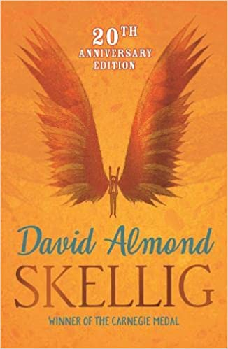
Key Quotes
‘They say that shoulder blades are where your wings were.’
‘Sometimes we think we should know everything. But we can’t.’
Context
Although the setting of the book remains incredibly normal, David Almond is keen to create a ‘dream-like’ sense in the opening of the book. The constant ambiguity of Skellig and of the health of the new-born baby keeps the reader in a constant state of the ‘unknown’. The juxtaposition of the derelict and the safe keeps us in two separate words at all times. William Blake is also mentioned throughout the book as a metaphor for freedom from restraint.
Themes
Life and Death – Throughout the story, Michael and Mina work to nurture Skellig back to life, whilst simultaneously his baby sister faces her own fight between life and death.

Key Characters
Michael – Protagonist – 10-year-old boy who loves football and cares about his new-born sister. He also helps Skellig.
Mina – Home-schooled neighbour with a creative flair and a love of poetry, drawing and an interest in birds.
Skellig – Antagonist? Depicted as a homeless man but Michael and Mina discover his wings and consider that he might be something else.
Michael’s Parents – Names are never given but they deeply care for Michael and the new-born baby.
Dr Dan/Dr Death – A family doctor who visits throughout the book.
Mrs Dando – A caring auxiliary teacher at Michael’s school.
Coot and Leakey – Michael’s best friends at school.

Plot summary
When a move to a new house coincides with his baby sister's illness, Michael's world seems suddenly lonely and uncertain. Then, one Sunday afternoon, he stumbles into the old, ramshackle garage of his new home, and finds something magical. A strange creature - part owl, part angel, a being who needs Michael's help if he is to survive. With his new friend Mina, Michael nourishes Skellig back to health, while his baby sister languishes in the hospital. But Skellig is far more than he at first appears, and as he helps Michael breathe life into his tiny sister, Michael's world changes for ever . . .
Skellig
By David Almond
D – Decode
E – Explain
R – Retrieval
I – Inference
C – Word Choice

