Key Vocabulary
brazenly | In a bold and shameless way.
derelict | Something in a poor condition due to disuse or neglect.
desperation | A state of despair causing extreme behaviour
dystopian | The opposite of a utopia. It has often become corrupt and is in crisis.
hassock | A cushion for kneeling on in church, while at prayer.
infernal | Hell like, diabolical.
manipulating | To manage or influence skillfully, especially in an unfair manner.
oarsmen | A rower of a boat using oars to move the boat.
resistance | The refusal to accept or comply with something
salvation | The state of being saved from harm.
scavenged | Search/collect anything usable from discarded waste.
sea-level | The level of the sea’s surface, used in reckoning the height of geographical features such as hills/mountains.
thwart | Prevent (someone) from accomplishing something.
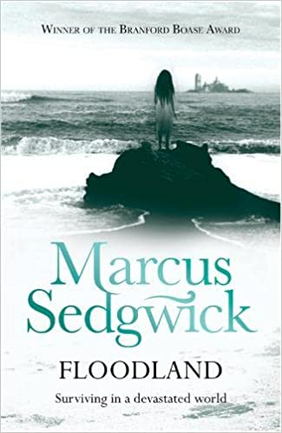
Key Quotes
‘I don’t think anyone took it seriously enough. By the time they did, it was too late. The world couldn’t cope anymore, by then.’

Context
Although the setting of the book remains incredibly normal, David Almond is keen to create a ‘dream-like’ sense in the opening of the book. The constant ambiguity of Skellig and of the health of the new-born baby keeps the reader in a constant state of the ‘unknown’. The juxtaposition of the derelict and the safe keeps us in two separate words at all times. William Blake is also mentioned throughout the book as a metaphor for freedom from restraint.
Key Characters
Zoe – Protagonist – Young English girl looking for her parents.
Dooby – Antagonist – Runs Eel Island, including the cathedral.
William – An older inhabitant of Eel Island seen by others as crazy.
Munchkin and Spat – Dooby’s henchmen.
Sarah – Inhabitant of Eel Island.
Natasha – Previous friend of Zoe.
The Cat – Enemy spy who is caught by Dooby.
Zoe’s parents – A terrible accident left Zoe behind as they escaped by boat.

Themes
Climate change and global warming.
Loneliness, courage, trust, perseverance. Life and Death.

Plot summary
Zoe runs from a group of people chasing her and escapes in her boat called ‘Lyca’ which she found and pathed up. The seas are rising and the world is running out of land. She lands on Eel Island where life is just as difficult and unsavoury characters are out to look after only themselves. Zoe explains that her parents accidentally left her behind when boats came to rescue them and she has been searching for them ever since.
Initially set in Norwich, the novel is set in an unspecified future where the sea is constantly rising and reducing the amount of inhabitable land.
Floodlands
By Marcus Sedgewick
D – Decode
E – Explain
R – Retrieval
I – Inference
C – Word Choice

