Key Vocabulary
asylum | A place that offers safety and protection given by one country to refugees from another.
bigotry | An intolerance of any belief or group that is not one’s own, particularly based on race, religion or gender.
camps | An outdoor area where many refugees set up tents or rough shelters to live in for a time.
conundrum | A confusing and difficult problem or question.
curious | To be eager to know or learn something new.
immigrant | A person who comes to live permanently in a foreign country.
influx | A continuous coming in of people, often used in a negative way.
justice | The upholding of what is fair and right and giving out what is deserved, whether that is a reward or punishment.
Kurdish | One of the languages spoken in the country of Syria.
opinion | A view or judgment formed about something which is not necessarily based on fact or knowledge.
refugee | A person who has been ordered to leave their country in order escape war or a natural disaster.
seclusion | A sheltered and private place in school that is away from other people.
Syria | A country in Western Asia where war is forcing man of the citizens to escape and seek safety in other countries.
turban | A long piece of material that is wrapped around the head of Sikh and Muslim men in particular.
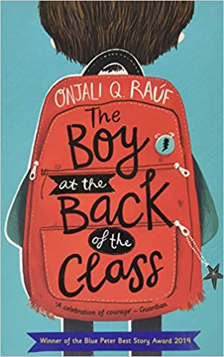
Context
Told with humour and heart, the text offers a child’s perspective on the refugee crisis, highlighting the importance of friendship and kindness in a world that doesn’t always make sense.
Refugees are often painted in a bad light, but there is a tragic human story behind the highest levels of displacement on record. Half of the world’s refugees are children and by 2019 there were nearly 26 million refugees in the world – this number has continued to climb. Why do people become refugees? People become refugees for a number of different reasons: war; ethnic or political violence; and persecution based on race, religion, nationality or social group.
Key Characters
Alexa – A 9-year-old who lives with her mum. Remains nameless through much of the story.
Ahmet – An initially timid and mysterious character, who doesn’t smile and who doesn’t speak English. He wonders what has happened to his family.
Tom, Michael and Josie – classmates who befriend Ahmet.
Brendan – The bully who targets Ahmet for being different.
Jennie – A classmate who initially states that Ahmet was likely dangerous.

Themes
Friendship and kindness in a world that doesn’t always make ense.
Judging a book by its cover. War and its consequences.

Plot summary
When Ahmet arrives in their class, a group of children are curious to know more about him – where he is from, what language does he speak and where is his family? As they learn more about him – that he is a Kurdish refugee from Syria and that he was separated from his family en route to Britain – their concern for him grows. When they hear that the gates to refugees are to be closed, they hatch a plan ‘The Greatest Idea in the World’ with the aim of ensuring that Ahmet can be reunited with his family.
Narrated by one of this group of children, this touching novel conveys the seriousness of the situation while maintaining a humorous tone when describing the scrapes they get into while trying to accomplish their mission.

The Boy at the Back of the Class
By Onjali Q. Rauf
D – Decode
E – Explain
R – Retrieval
I – Inference
C – Word Choice

