Key Vocabulary
Ammunition | A quantity of bullets, shells or explosives
Artillery | Artillery consists of large, powerful guns which are transported on wheels and used by an army.
Bombardment | A strong and continuous attack of gunfire or bombing.
Barbed wire | Wire with clusters of short, sharp spikes set an intervals used to create an obstruction and slow down the enemy advance.
Cavalry | Soldiers mounted on horseback
Colt | A male horse, usually below the age of four years.
Halter | Headgear that is used to lead or tie up livestock and other animals.
Hind | The back end of the horse, sometimes the back legs.
Infantry | Soldiers who fight on foot rather than in tanks or on horses.
No-man’s-land | An narrow ditch dug in the ground in which the soldiers lived and fought.
Trench | A narrow ditch dug in the ground in which soldiers lived and fought.
World War I | A global conflict from 1914-1918 in which the main protagonists were Britain and her allies, and Germany and her allies.  Also known as ‘The First World War’, ‘The Great War’ or ‘The War to end all wars’.
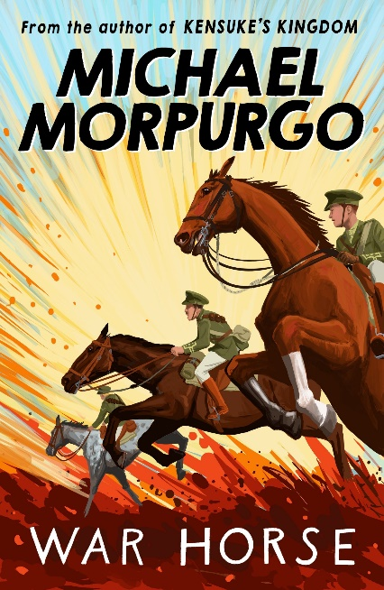
Context
The use of trench warfare had a major influence on how war was carried out and changed the use of horses as a key form of attack. Both sides dug deep defensive lines in the soil and the use of machine guns and shells meant that the death toll was high.
Prior to WW1, horses had been used by the cavalry as a quick and effective strategy in winning battles. With the introduction of trenches, barbed wire and machine guns, this form of attack became useless. Instead, they were used to haul artillery to the front line, aid transportation of the injured and help with logistical support. Hundreds of thousands of horses were killed or injured during the war.
Key Characters
Joey – A young farm horse with distinctive markings. The story is told through the eyes of Joey (the narrator).
Arthur – The son of a farmer, Albert has a gentle nature and forms a deep and lasting bond with Joey.
Mother (Mrs Narracott) – A quiet character who has an inner strength to lead the family.
Father (Mr Narracott) – Albert’s father – he is a bully and has little empathy or respect for others.
Captain Nicholls – He buys Joey from Mr Narracott and cares and protects Joey.

Plot summary
Joey is a young farm horse whose earliest memory is of being taken to the town marketplace with his mother while an auction that he did not fully understand took place around him. Two men bid feverishly against each other until the auctioneer brings down his hammer and Joey is led away from his mother.
Joey’s new home is a farm and he soon forms a deep bond with the farmer’s son, Albert. But then, the First World War begins and Joey is sold to the army. Through his eyes, the reader experience the devastation of the Western Front, his capture by the Germans and his entrapment in No Man’s Land.

War Horse
By Michael Morpurgo
Themes
Relationships – The story explores the deep and lasting relationships between a horse and his rider. Joey and Albert form an emotional bond from the very beginning, and each demonstrate his commitment, loyalty and love to each other.
The futility of war – When war is announced, the hopelessness of war is discussed. Joey sees soldiers on both sides and sees very little difference between them.
D – Decode
E – Explain
R – Retrieval
I – Inference
C – Word Choice

