Key Vocabulary
ancestor | A person from whom one is descended (great relatives).
bellowing | To make a deep, loud shout or cry
bristled | When hair is or becomes short and stiff on an animal.
corrupted | Someone that has become disloyal or dishonest.
deliberately | To do something on purpose
enthralled | Excited and captivated by something
forage | To hunt and look for something
intoxicating | An experience which takes over the body and mind.
potent | Having strength or power (often used for smell or taste).
rancid | An unpleasant odour or taste due to it rotting.
spluttered | To make spitting noises or unable to get words out.
swaggering | Over confident mannerisms.
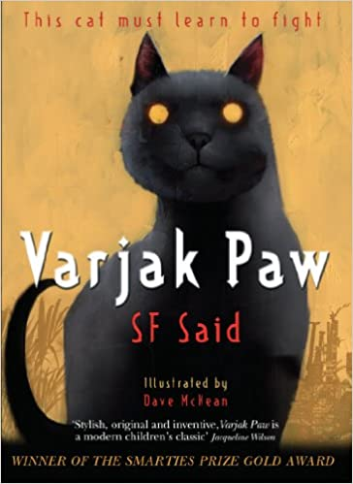
What can we learn from the book?
With courage and belief, anything is possible.

Key Quotes
“Believe something is impossible,” said his ancestor calmly, “and you will surely fail. But believe in yourself and you can do anything.”
‘Outside! For the first time since Jalal, a paw stood on the edge of the world.’

Context
S.F. Said took 5 years to write the book and created 17 drafts of his story before it was published. He was inspired by watching his own cat (whom he named Varjak Paw) when it was a kitten and its adventures of going outside the house for the first time. Mesopotamian Blue is a made-up cat breed (although there is the Persian Blue). Mesopotamia is the historical land between the Tigris and Euphrates Rivers where the oldest known civilizations and stories began.
Key Characters
Varjak Paw – Protagonist – A young ‘Mesopotamian Blue’ kitten with amber eyes.
Elder Paw – Varjak’s grandfather who is wise and knows something is wrong.
Jalal the Paw – Ancestor of Varjak who teachers him ‘The Way’ through dreams.
The Contessa – An old lady who feeds the cats who unexpectedly dies.
Julius – Antagonist – Varjak’s brother who is always making fun of him.
The Gentleman – A man who turns up at the house with two black cats after Contessa’s death.

Themes
The main themes are rebellion, perseverance, courage, family, exploration and friendship.

Plot summary
When the Contessa dies in the house where a family of Mesopotamian Blue cats live, a gentleman arrives with two mysterious black cats. Both Varjak and the Elder Paw realise something is wrong and Varjak begins to communicate with his ancestor Jalal, who trains him in cat martial arts known as ‘The Way’. Varjak leaves the house on an unforgettable adventure into the unknown where he uncovers the ‘vanishings’.
Varjak Paw
By S.F. Said
D – Decode
E – Explain
R – Retrieval
I – Inference
C – Word Choice

