Key Vocabulary
adoration | A feeling of great admiration and love for someone or something
breeches | Short trousers fastened just below the knee
crook | A person who is dishonest or is a criminal
chasten | Restrain
discipline | The practice of making people obey rules or standards of behaviour, and punishing them when they do not.
devising | Making a plan
formidable | If you describe something or someone as formidable, you mean that you feel slightly frightened by them because they are very great or impressive.
ignorant | If you describe someone as ignorant, you mean that they do not know things they should know. If someone is ignorant of a fact, they do not know it.
indelible | Something that can not be forgotten.
intrigue | If something, especially something strange, intrigues you, it interests you and you want to know more about it.
paraffin | A flammable, whitish, oily liquid that is used as fuel. It is highly flammable
prodigy | An unusually gifted or talented person
skulduggery | The use of dishonest methods and tricks in order to achieve something.
tyrannical | A person who is severe or unfair towards the people that they have authority over
unaccompanied | Alone, by herself
welts | A mark which is made on someone’s skin
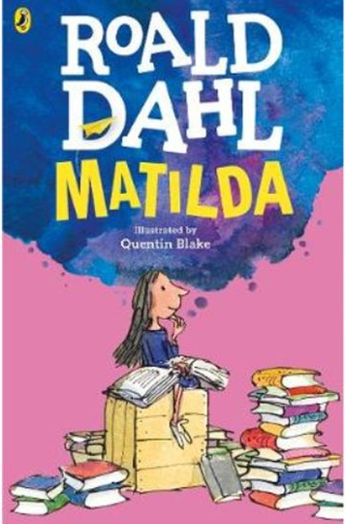
D – Decode
E – Explain
R – Retrieval
I – Inference
C – Word Choice
Key Characters
Matilda – the protagonist with a special ‘talent’ who loves reading
Miss Honey – her teacher who supports and fosters Matilda’s intelligence.
Miss Trunchbull – the Headmistress and lead antagonist
Mr and Mrs Wormwood – Matilda’s negligent parents
Lavender – Matilda’s friend at school
Mrs Phelps – the librarian who supports Matilda’s love for reading

Themes
Good triumphs over evil. Love, friendship, resilience, education, family, fear and freedom.
Context
This was the last book Roald Dahl wrote before he died. The book was inspired by the political climate of the 1980s where some countries had strict rules that it imposed upon its citizens. Also, Dahl feared the phasing out of books, which perhaps influenced Matilda being a voracious and intelligent reader. Dahl frames television as a terrible thing and encourages children, through Matilda’s special talents, to read more.
Matilda
By Roald Dahl
Plot summary
Sweet and bright little girl, Matilda Wormwood, a child of wondrous intelligence, is different from the rest of her family. Since her parents don’t pay much attention to her, Matilda teaches herself to read. Before she has even been to elementary school, she has already read many books in the local library which she visits every afternoon. Matilda’s parents think she should read less and watch more television.
Misunderstood by everyone and ignored at home all the time, Matilda escapes into a world of reading, honing her skills and exercising her mind so much that she develops telekinetic powers.
Using these skills and with the support of her thoughtful teacher, Miss Honey, Matilda decides to punish her parents for the way they treat her – she hopes that it will make them less selfish and mean.

