Key Vocabulary
abide | To put up with, tolerate, follow.
appeased | To satisfy, bring to a state of peace.
centaur | A mythical creature, half man, half horse
decoy | A person who lures another person or thing into danger or trap.
dominions | Lands under the rule of a king or queen
evacuation | To move or take away from a dangerous place.
faun | A man with a goat’s horns, ears, legs, and tail
gilded | Covered with a thin layer of gold
melancholy | In a sad state of mind
mothball | Small, Styrofoam-like balls containing chemicals to keep moths away from clothing in storage.
prophecy | A prediction of what will happen in the future.
reign | Rule by a king or queen, to have complete and widespread control or influence.
renounce | Give up
savagely | Cruel, uncivilized
scornfully | To look at with ridicule as if beneath oneself.
treason | Betrayal of a ruler or government
treacherous | Guilty of or involving betrayal or deception
Turkish delight | A cube shaped candy made of fruit juice and gelatin
World War II | A global conflict fought between 1939 and 1945
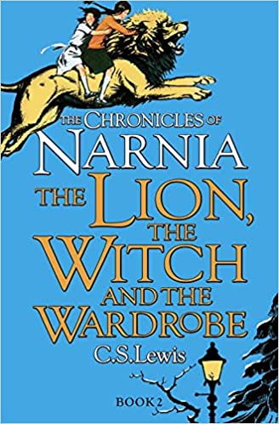
Key Discussion Points:
Would you forgive Edmund?
Why does Aslan sacrifice himself?
Who is the bravest character in the story and why?
Context
C.S. Lewis first had the idea to write a book for children in 1939. At this time, many children were evacuated from England’s major cities and sent to live in the countryside because of the threat of bombing during World War II. Lewis had opened his home, The Kilns, to some of these young refugees, one of whom had been fascinated by a wardrobe there, imagining that there was another way out of it through the other side.

Key Characters
Lucy – The youngest of the four siblings – the primary protagonist
Edmund – Second youngest – he betrays his siblings to help the White Witch.
Susan – Second oldest – she helps care for Aslan at the stone table.
Peter – Oldest siblings – leads the battle against the White Witch.
Aslan – The rightful King of Narnia and other magic countries.
The White Witch – The primary antagonist of the story, this evil queen places a spell on the land so that it is always always but never Christmas. The witch is the ‘Emperor’s hangman’, as Mr Beaver says, and she has the right to kill any Narnian traitor.
Tumnus – A faun who initially intends to kidnap Lucy and bring her to the White Witch, but he does not go through with it and pays for his weakness by being cursed.

Themes
Friendship, loyalty, good judgment, forgiveness, faith, courage, and self-sacrifice.

Plot summary
During the World War II bombings of London, four English siblings are sent to a country house with eccentric Professor Kirke. Whilst exploring the house one rainy day, the youngest (Lucy) discovers an enormous wardrobe, which leads them to a magical, snowy world called Narnia.
The false ruler keeps the land in perpetual winter. They must support the true ruler, a lion called Aslan, to defeat her.
The Lion, the Witch and the Wardrobe by C.S. Lewis
D – Decode
E – Explain
R – Retrieval
I – Inference
C – Word Choice

