Key Vocabulary
Astronomer | A scientist who studies the stars, planets and other natural objects in space.
blissful | Extremely happy, full of joy.
brink | The extreme edge of land before a steep slope or a body of water.
constellation | Group of stars forming a recognisable patter.
harmony | The combination of simultaneously sounded musical notes to produce a pleasing effect.
hillock | A small hill or mound
hush | A silence
infrared | Rays like light but outside the visible spectrum at the red end/although we cannot see it, we can feel it as heat.
petroleum | A dark, thick oil obtained from under the ground, from which various substances, including petrol, are produced.
scrap metal | Discarded waste metal suitable for reprocessing
torso | The trunk of the human body (ribs, navel etc.)
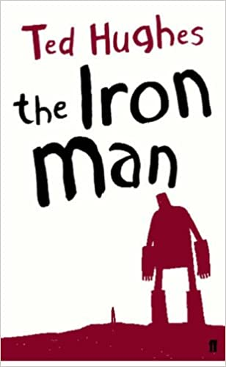
Themes
Bravery, prejudice, irrational fear, inclusion.
Not to fear people who are different to yourself, but to learn to understand and accept them.
The futility of war – intelligence can succeed where weaponry fails.

Key Characters
The Iron Man – The giant “metal man” of unknown origin.
Hogarth – The young, local boy who lures the Iron Man and strikes up a relationship with him.
Hogarth’s family – Hogarth has a father, mother ans sister.
Space-Bat-Angel-Dragon – The space-being who resembles a dragon.
Farm hands – Hatch a plan to trap and bury the Iron Man.
Armed forces – Sent to destroy the strange creature from the sky.

Key Quotes
‘The Iron Man came to the top of the cliff. How far had he walked? Nobody knows. Where had he come from? Nobody knows. How was he made? Nobody knows.’
‘If you’re all so peaceful up there, how did you get such greedy and cruel ideas?’
Context
Ted Hughes is primarily known as one of the best poets of the last century, but he also created many stories for children. The Iron Man was a story for his own small children, and he later wrote it out just as he had told it over three or four nights. He described the story as ‘like a kit or blueprint for putting together a little boy.’, and said that he felt he should tell his children stories to make things possible for them; stories that allowed them to win.
Later, he wrote the Iron Woman as a sequel to the Iron Man.
Plot summary
Mankind must put a stop to the dreadful destruction caused by the Iron Man…
An Iron giant appears from seemingly nowhere, feeding on local farm equipment. A trap is set and he is buried, although he eventually escapes. A small boy called Hogarth has the idea of sending him to a scrapyard to feed him metal and keep him out of the way. Meanwhile a giant dragon appears to get larger in space and makes it’s way to earth. The Iron Man is suddenly called upon to help save the world.
The Iron Man
By Ted Hughes
D – Decode
E – Explain
R – Retrieval
I – Inference
C – Word Choice

