Key Vocabulary
altered | To make changes to something such as clothing.
bulletin board | A notice board used to display pictures and notes.
disguise | To change or hide the looks of in order to prevent recognition
examination | A detailed inspection usually carried out by a doctor or nurse.
jealous | Feeling or showing resentment for someone because of their belongings or achievements.
politeness | Behaviour that is considerate and respectful.
valuable | Worth a lot of money.
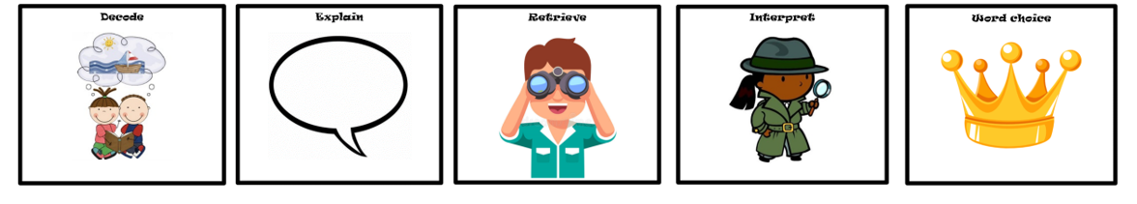
Key Characters
Stanley Lambchop – Protagonist – The main character who becomes flat when a bulletin board fell on him.
Dr Dan – The doctor who examines Stanley.
Mr Dart – The director of the Famous Museum
Max and Luther – The sneak thieves that try to steal the most expensive painting in the world.
Thomas Jeffrey – The friend that Stanley mails himself to in California.

Context
Jeff Brown created the character of Flat Stanley when his son joked that he thought the bulletin board over his bed would fall on him and flatten him in his sleep. The joke was so funny, Mr. Brown decided to write a story about what would happen if a bulletin board actually did flatten a sleeping boy, and Flat Stanley was born. Flat Stanley was originally published in 1964. It took two decades for Jeff Brown to continue the Flat Stanley series.
Themes
Discrimination Adventure Bullying

Plot summary
A flat boy can do almost anything!
Stanley Lambchop is an ordinary boy. At least he was, until the night his bulletin board fell off the wall and flattened him. All of a sudden, Stanley can slide under doors, mail himself across the country in an envelope, and fly like a kite!
But flatness has its serious side, too. Sneak thieves have been stealing paintings from the Famous Museum of Art, and Stanley knows he's the only one who can stop them. Will the robbers discover Stanley's plan before he foils theirs?

D E R I C
Flat Stanley
By Jeff Brown

