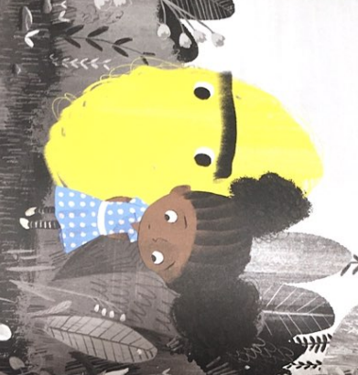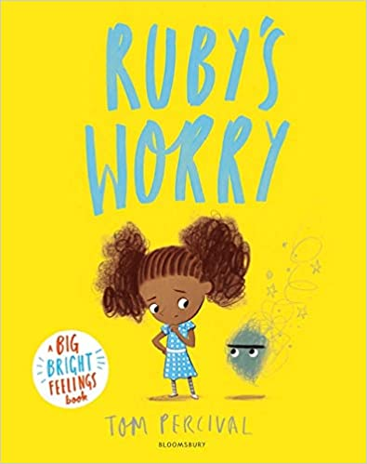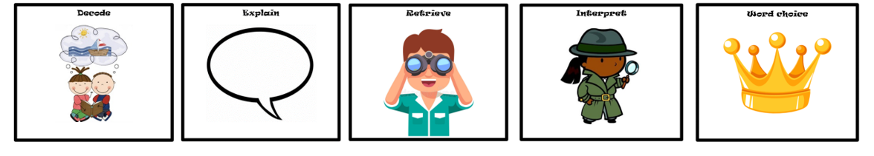

**Plot summary**

Ruby is a curious and happy-go-lucky girl. She loves swinging as high as you can go and exploring her surroundings. Ruby loves being Ruby. But one day, she finds a worry, something she had never seen before. It wasn’t all that big, but despite ignoring it, it stayed with her all day.

No one else could see her Worry so Ruby tried to ignore it. The more she ignored the Worry, it grew bigger and bigger. It followed her everywhere, stopping her from doing the things she loved. Soon the Worry was so ENORMOUS and overwhelming it was all she could think about. What Ruby didn’t realise was this is the worst thing you can do with a Worry.

The worry makes Ruby feel sad. How can she get rid of it and feel like herself again?

**Themes**

Friendship Communication

Problem solving Emotions

Ruby’s Worry

By Tom Percival

**Think aloud questions:**

* Why do you think Worry starts with a capital letter?
* What hasn’t Ruby’s Worry gone away forever?
* What strategies did Ruby learn to cope with her Worry?
* What lessons have you learned from Ruby’s Finds a Worry?

D E R I C